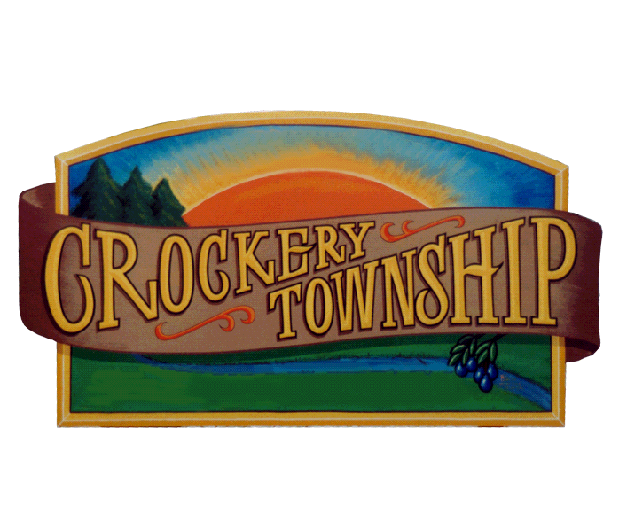

CROCKERY TOWNSHIP

COMPREHENSIVE PLAN

December 2013

Prepared through the Efforts of the:

CROCKERY TOWNSHIP PLANNING COMMISSION
Bill Sanders, Chairman
Jon C. Overway, Secretary
Roy Holmes
Mike Munch
David Meekhof
Ryan Arends
Rich Suchecki

With Assistance From:

TOWNSHIP PLANNER/ZONING ADMINISTRATOR
Robert R. Toland

With the Support of the:

CROCKERY TOWNSHIP BOARD
Leon Stille, Supervisor
Kathy Buchannan, Clerk
Judy VanBemmelen, Treasurer
Gordy Constantine, Trustee
Rich Suchecki, Trustee

Crockery Township
17431 112th Avenue
Nunica, MI 49448
616-837-6868

TABLE OF CONTENTS Page

Chapter 1 - FORWARD

Introduction 1
Mission Statement 3
Plan Purpose 4
Community Assets 7

Chapter 2 - DESCRIPTION OF CROCKERY TOWNSHIP

Regional Setting 8
Historical Background 8
Topography, Drainage and Soils 14
Groundwater Quality 15
Public Utility Services and Facilities 19
Transportation System 22
Housing 25
Economic Characteristics 25
Existing Land Use 26

Chapter 3 – TRENDS AND REGIONAL ASPECTS

Adjacent Township Zoning and Land Use 30
Population and Housing Growth Trends 30
Anticipated Development 31
Community Context 32
Public Utility Capacity 32
Regional Real Estate Market 33

Chapter 4 – PUBLIC PARTICIPATION

Development Issues and Resource Presenters 34
Community Questionnaire 34
Summary of Questionnaire Responses 34

CHAPTER 5 - PLANNING DIMENSIONS

Growth Policy 37
Vision Statement 38
Goal Statements 38
Policy Statements and Planning Goals 39
Planning Goals 39
Agricultural Preservation Policy 40
Residential Land Use Policy 41
Commercial Land Use Policy 41
Industrial Land Use Policy 42
Environmental Policy 42
Recreational Facility Policy 42
Transportation Systems Policy 43
Public Utilities, Facilities, and Services Policy 43
Rural Character Preservation Policy 44
Natural Resource Protection Policy 44

CHAPTER 6 – MANAGEMENT RECOMMENDATIONS

Plan Concepts 46
Providing for Housing Choices 47
Connectivity (Linking People and Places) 48
Parks, Paths and Trails 49
Recreational Development 50
Anticipated Development 50
Diversity of Housing 51
Commercial Development to Create Space 51
Encourage Redevelopment 52
Residential Development and Densities 52
The Mixed-Use Zoning District Option 53
Recreation Areas 54
Open Space Preservation 54
Rural Preservation Routes 54
Road Connections 56
Corridor Access Management and Corridor Improvement Authority 56
Proposed Commercial Development 57
Commercial Nodes versus Sprawl 59
Business and Industry 59
Community Gateways 60
Interchange Image 60
Wetland Management 60
Floodplain Management 61
Development Staging 61
Clustering/Open Space Development 62
Lot Averaging/Lot Sizes 64
Planned Unit Development (PUD) 64
Development Agreements 65
Hazard Mitigation………………………………………………………………………………………66

CHAPTER 7 – LAND USE NEEDS

Residential 67
Commercial 67
Industrial 68
Agricultural 68
Transportation 69
Recreation 70

CHAPTER 8 – ZONING PLAN

Agricultural Preservation (Agriculture 1) 72
Moderate Agriculture (Agriculture 2) 73
Rural Estate (Single-Family) (R-1) 74
Low Density Single-Family (R-2) 75
Moderate Density Single-Family (R-3) 75
Multiple-Family Mixed-Use (R-4) 77
Village Mixed Use (R-5) 78
Neighborhood Commercial (C-1) 79
General Commercial (C-2) 80
Highway Commercial (C-3) 81
Commercial Horticulture (CH) 81
Industrial Districts (I-1) 82
M-104 Corridor Overlay (MCO) 83
Floodplain Overlay (FPO) 84

CHAPTER 9 – PUBLIC INFRASTRUCTURE IMPROVEMENTS

Capital Improvements 87
Proposed Projects 87
LIST OF FIGURES

Figure Page

1 Township Location 9
2 Watersheds and Drainage 16
3 Agricultural Analysis 17
4 Groundwater 18
5 Water System 20
6 Sanitary Sewer System 21
7 Road Classifications 23
8 Adjacent Township Growth rates 24
9 Existing Land Use 28
10 Public and Institutional Lands 55
11 Future Land Use Map 86

LIST OF TABLES

Table Page

1 Population in Townships Surrounding Crockery Township 22
2 Housing Characteristics 25
3 Income and Poverty 26
4 Land Use Acreages 27
5 Population Density and Housing 27
6 Population Trends 31
7 Existing Recreation Facilities 70

CHAPTER 1
FORWARD

Introduction - Attractive and desirable communities are difficult to achieve and even harder to maintain. Conscientious and deliberate long-range planning is required. It is this basic premise that has prompted the Crockery Township Planning Commission to update its Comprehensive Plan, also known as a “Master Plan”.

Crockery Township has many attributes and opportunities which continue to make the community an attractive and desirable place to live. However, the Township is also faced with numerous challenges. The responsibility of making various policies and decisions regarding growth and development is therefore an important one. The on-going need for such things as public utilities, new and improved streets, parks and recreation areas and community facilities are generally recognized, but fulfilling these needs requires hard work and effort.

Equally important are the decisions made regarding the various spatial relationships between the major land use types: residential, agricultural, public, commercial, and industrial. These are important in providing a harmonious pattern of land use and in the economics of providing community services.

The following statements, questions, and observations summarize the assets, problems, and issues inherent to the community. Their enumeration helps to provide focus in the processes of developing and implementing the Comprehensive Plan.

The Crockery Township Comprehensive Plan is an official advisory statement for encouraging orderly and efficient use of land for residences, business, industry, community facilities, parks and recreational areas, and for coordinating these uses with each other and with the development and use of streets, utilities and other public facilities and services. The Comprehensive Plan is intended to serve the needs of Township residents in accordance with present and future needs. The Comprehensive Plan should promote the public health, safety, morals, order, convenience, prosperity, and general welfare.

As such, the Plan contains goals and recommendations for the physical development of the Township and is designed to provide direction for growth and development in accordance with these goals and recommendations. A Comprehensive Plan also includes the following subjects that are considered pertinent to the future development of Crockery Township. The Plan contains a classification and allocation of land for:

- agriculture
- residences
- commerce
- industry
- recreation
- thoroughfares
- public buildings and public property
- schools
- soil conservation
- forests
- woodlots
- open space
- wildlife refuges
- other uses and purposes

The Plan also includes the general location, character, and extent of:

- streets
- airports
- bicycle paths
- pedestrian ways
- bridges
- waterways, and waterfront developments
- sanitary sewers and water supply systems
- facilities for flood prevention, drainage, pollution prevention, and maintenance of water levels
- public utilities and structures

The physical features of Crockery Township are characterized as having a high ground water table, heavy soils, floodplains, wetlands, and numerous streams and creeks flowing to the Grand River. The Plan includes recommendations as to the general character, extent, and layout of redevelopment or rehabilitation of blighted areas; and the removal, relocation, widening, narrowing, vacating, abandonment, change of use, or extension of streets, grounds, open spaces, buildings, utilities, or other facilities.

It is the Township’s intent to implement the Plan’s recommendations until specific modifications or deviations are deemed appropriate and the Plan is amended because of the Township’s on-going long-range planning program.

- The Comprehensive Plan is general in scope and therefore not intended to establish precise boundaries of land use areas or exact locations of future shopping centers, school sites, or other projected development. Its function is to guide growth toward long-range, broad goals. It establishes the framework required to assure that decisions that are more detailed could be related to the broader scene.

- This is not a zoning document but is intended to guide decision-making regarding zoning.

- As required by law, the Plan will include a zoning plan for various zoning districts controlling the height, area, bulk, location, and use of buildings and premises. The zoning plan will include an explanation of how the land use categories on the Future Land Use map relate to the districts on the zoning map within each planning category designated in this plan.

Mission Statement - The purpose of this Comprehensive Plan is to serve as a guide for development in Crockery Township and its environs by promoting the health, safety, and general welfare of its citizens. Long-term planning is achieved through the study of past and present conditions, yielding a vision of the future. The Plan must remain flexible enough to accommodate a myriad of particulars in an ever-changing world. The Comprehensive Plan seeks the highest quality of life in Crockery Township.

The mission of Crockery Township is to promote land use development which:

- Enhances the quality of life
- Promotes a clean safe environment
- Preserves and maintains Crockery’s unique qualities
- Achieves a balance between development and rural living
- Provides for continuation of farming while guiding probable growth

The success of the plan will be measured by its ability to retain the good character and qualities of the community while encouraging growth that benefits all its residents.

Plan Purpose - Through the study of past and present features and conditions of the local geography, environment, economy, society, public need, and individual desire, a vision of the future unfolds. The Comprehensive Plan is to serve as a guide in developing policies concerning such factors as trends in land use, population, development, transportation, recreation, public utilities, the wise use of resources, good civic design, and wise and efficient expenditure of public funds. The Plan must remain flexible enough to accommodate a myriad of particulars in an ever-changing world. The Comprehensive Plan seeks to achieve the highest quality of life in Crockery Township.

The general purpose of a Comprehensive Plan is to guide and accomplish, in the planning jurisdiction and its environs, development that satisfies all of the following criteria:

- Is coordinated, adjusted, harmonious, efficient, and economical.

- Considers the character of the planning jurisdiction and its suitability for particular uses, judged in terms of such factors as trends in land and population development.

- Will, in accordance with present and future needs, best promote public health, safety, morals, order, convenience, prosperity, and general welfare.

- Includes, among other things, promotion of or adequate provision for 1 or more of the following:

- A system of transportation to lessen congestion on streets
- Safety from fire and other dangers
- Air and Water Quality
- Healthful and convenient distribution of population
- Good civic design and arrangement and wise and efficient expenditure of public funds
- Public utilities such as sewage disposal and water supply and other public improvements
- Recreation.
- The use of resources in accordance with their character and adaptability

In the preparation of a Comprehensive Plan, a Planning Commission shall do all of the following, as applicable:

- Make careful and comprehensive surveys and studies of present conditions and future growth within the planning jurisdiction with due regard to its relation to neighboring jurisdictions.

- Consult with representatives of adjacent local units of government in respect to their planning so that conflicts in master plans and zoning may be avoided.

- Cooperate with all departments of the state and federal governments and other public agencies concerned with programs for economic, social, and physical development within the planning jurisdiction and seek the maximum coordination of the local unit of government's programs with these agencies.

In general, a Planning Commission has such lawful powers as may be necessary to enable it to promote local planning and otherwise carry out the purposes of Public Act 33 of 2008, as amended. A Comprehensive Plan shall address land use and infrastructure issues and may project 20 years or more into the future. A Comprehensive Plan shall include maps, plats, charts, and descriptive, explanatory, and other related matter and shall show the Planning Commission's recommendations for the physical development of the planning jurisdiction.

A Comprehensive Plan shall also include those of the following subjects that reasonably can be considered as pertinent to the future development of the planning jurisdiction:

- A land use plan that consists in part of a classification and allocation of land for agriculture, residences, commerce, industry, recreation, ways and grounds, public buildings, schools, soil conservation, forests, woodlots, open space, wildlife refuges, and other uses and purposes.

- The general location, character, and extent of streets, railroads, airports, bicycle paths, pedestrian ways, bridges, waterways, and waterfront developments; sanitary sewers and water supply systems; facilities for flood prevention, drainage, pollution prevention, and maintenance of water levels; and public utilities and structures.

- Recommendations as to the general character, extent, and layout of redevelopment or rehabilitation of blighted areas; and the removal, relocation, widening, narrowing, vacating, abandonment, change of use, or extension of streets, grounds, open spaces, buildings, utilities, or other facilities.

- For a local unit of government that has adopted a zoning ordinance, a zoning plan for various zoning districts controlling the height, area, bulk, location, and use of buildings and premises. The zoning plan shall include an explanation of how the land use categories on the future land use map relate to the districts on the zoning map.

- Recommendations for implementing any of the Comprehensive Plan's proposals.

The Comprehensive Plan shall be designed to:

- Promote the public health, safety, and general welfare
- Encourage the use of lands in accordance with their character and adaptability
- Promote the best use of land
- Conserve natural resources and energy
- Meet the needs of the state's residents for food, fiber, and other natural resources, places of residence, recreation, industry, trade, service, and other uses of land
- Insure that uses of the land shall be situated in appropriate locations and relationships
- Avoid the overcrowding of population
- Provide adequate light and air
- Lessen congestion on the public roads and streets
- Reduce hazards to life and property
- Facilitate adequate provision for a system of transportation, sewage disposal, safe and adequate water supply, education, recreation, and other public requirements
- Conserve the expenditure of funds for public improvements and services Conform to the most advantageous uses of land, resources, and properties

Community Assets - Location: Crockery Township’s proximity to Grand Rapids, Muskegon, Holland, Lake Michigan, Grand Valley State University and the Grand Haven/Ferrysburg//Spring Lake Area communities offer residents easy access to a diversity of educational, cultural, social, employment and recreational opportunities seldom available to most rural communities. Proximity to Lake Michigan is an asset.

The Grand River: The Grand River and its floodplain offer residents scenic and recreational opportunities.

Room for Growth: The Township’s rural openness is highly valued by residents and intended to be preserved. However there is also ample room to accommodate diverse types of future growth and development.

Existing Utilities: The Township has in place a public water system that presently serves nearly one-third of its residents and a limited sanitary sewer system that could be expanded.

CHAPTER 2
DESCRIPTION OF CROCKERY TOWNSHIP

Regional Setting - Crockery Township (T 8 N, R 15 W) is one of the northern townships in Ottawa County, Michigan, having Muskegon County as its northern boundary, Polkton Township on the east, the Grand River for its southern boundary and Spring Lake Township on the west (Figure 1 Township Location). The Township lies 10 miles from the City of Muskegon, 16 miles from the City of Holland, and 18 miles from Grand Rapids. The Grand Haven urban area is about 8 miles west of the center of the township and Coopersville is about 8 miles to the east. The Grand River forms the southern boundary with Allendale Charter Township to the southeast, Robinson Township to the south, and Grand Haven Charter Township to the southwest. Lake Michigan is approximately 5-1/2 miles west of Crockery Township. The unincorporated settlement of Nunica is located in the east central portion of the Township.

Historical background - It is possible that the word Nunica is derived from an Odawa Indian word menonica which signifies the clay used by the Indians to make pottery. By natural progression then, it is possible to conclude that the name Crockery comes from the large amounts of pottery and earthenware found on the banks of Crockery Creek.

Originally, most of the township was covered in pine, hemlock, beech, and maple, interspersed with oak openings. The first pioneers came to the area approximately 11,000 years ago. Evidence of their presence comes from two small finds along the Grand River near Crockery Creek. Known to archaeologists as Paleo-Indians, these people lived in small groups collecting wild plants as they ripened and hunting game animals for meat, skins, bone, and sinew. During the long period known as the Archaic (from about 8000 BC to approximately 600 BC), people living in Crockery Township relied on a variety of abundant plants including nuts, berries, seeds and possibly maple sugar.

Sometime around 600 BC a revolution occurred throughout eastern North America that eventually spread to Crockery Township. The revolution brought new technology, new burial customs and new foods to the area. It was during this time that the people began to manufacture pottery, bury the dead in sacred burial mounds, and eventually grow a variety of plants which were imported from other areas including corn and squash.
Figure 1
Township Location
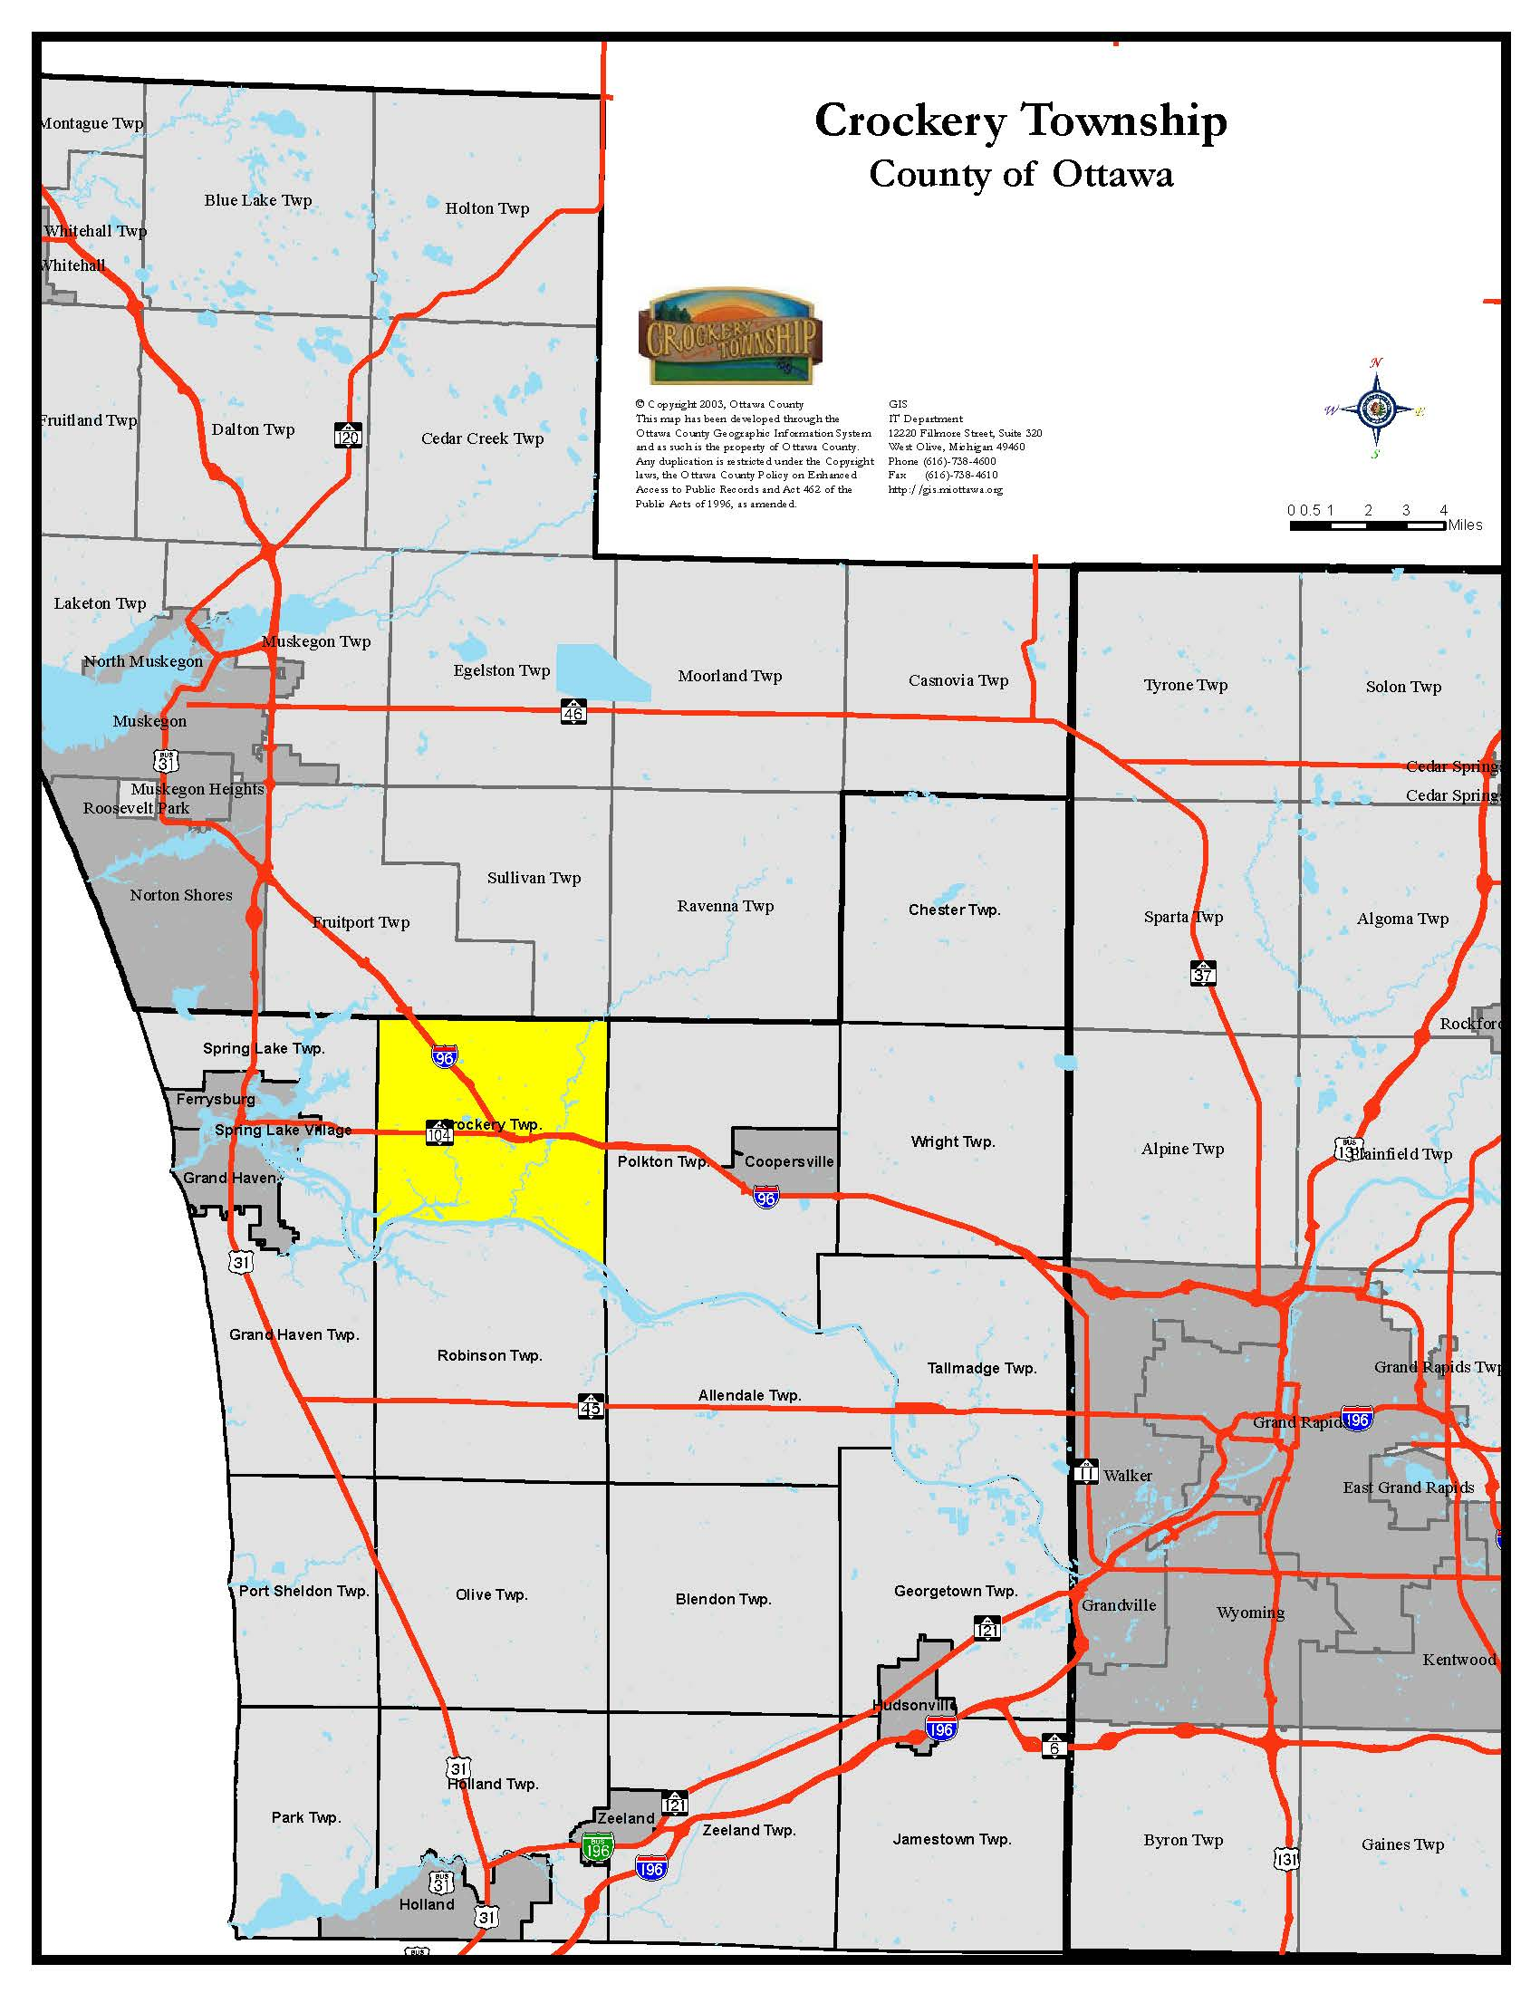
There is no written account of the native people in the township until the late 18th century. By that time, the Ottawa had migrated south from Georgian Bay and established themselves in the western portions of Michigan along the rivers and Lake Michigan shore. When explorers and traders from Europe came to West Michigan, three main groups of Indians lived here. They were the Ottawa, the Potawatomi, and the Ojibwa (often called the Chippewa). Without the help of friendly Indians, the very early white traders and explorers might well have starved to death. The Indians taught them how to raise corn, which was unknown to Europeans, and which wild plants and fruits were edible. The first European explorers in the Ottawa County region were the French-Canadian explorers Louis Joliet and Father Jacques Marquette who passed through the region in the mid-17th century.

The first trader in Ottawa County was believed to be Pierre Constant, a Frenchman, who was associated with the British Fur Company. Another early fur trader was Joseph LaFramboise and his wife Madeline Marcotte. Joseph was in charge of the Indian trade in western Michigan for the American Fur Company, headquartered on Mackinac Island. In the fall of 1809, Joseph and Madeline La Framboise (1781–1846), along with their infant son, Louis, left Mackinac Island for their trading post on the Grand River. Before arriving, Joseph was killed by a renegade Indian. Madame LaFramboise, knowing she was near the trading post, traveled on. Madeline La Framboise took over the trading business at the mouth of Crockery Creek and became very successful. She was of mixed French and Native American descent, and became one of the most successful fur traders in the Northwest Territory. Fur trading was one of the most difficult and dangerous occupations of the time. Still, she was one of the most prominent early businesswomen of Michigan. La Framboise was born in February 1781 at Mackinac Island, after her parents were removed from St. Joseph by the British. Her father was Jean Baptiste Marcotte (1720–1783), a French fur trader. Her mother was Marie Nekesh (circa.1740 - circa. 1790), an Odawa. Madeline was baptized August 1, 1786, on Mackinac Island. She was raised in a Lac Courtes Oreilles village at the mouth of Crockery Creek on the Grand River. She married Joseph La Framboise (1765–1806) in 1794. On September 24, 1795, they had their first child, a daughter, Josette La Framboise (1795–1820).Then in March 1805 they had a son, Joseph La Framboise (1805–1856). Although they considered themselves married already, Madeline and Joseph had their marriage solemnized on July 11, 1804, by a Catholic priest on Mackinac Island. Madeline and Joseph owned many trading posts in west Michigan. Every fall they would travel with their merchandise to trade with the Ottawa Native Americans from Mackinac Island down to the Grand River to what is now Ada, Michigan, where they built another trading post. It was the first permanent mercantile building in the west Michigan area. Every spring they would return to Mackinac Island with the furs they traded for. She continued to manage several trading posts, and expanded her business throughout the western and northern portions of Michigan's Lower Peninsula, while raising two children on her own. In a time when an experienced fur trader earned about $1,000 per year (which was a large sum at the time), La Framboise was earning $5,000 to $10,000 per year. La Framboise, eventually owned a string of trading posts in the Grand River Valley and was reputed to be no ordinary woman — probably for succeeding in an exclusively male trade in the "pays d'en haut" or savage country. She was acknowledged by the fur trade society, agents as well as Indians, as an intelligent worker in the trade, who was always fair in her dealings. La Framboise spoke four languages fluently; French, English, Ottawa, and Chippewa, but could not read or write in any language. Although confronted with strong competition from John Jacob Astor's American Fur Company monopoly, La Framboise ran a very successful business until 1818, when the American Fur Company convinced her to merge or sell out. Rix Robinson, another Michigan pioneer consummated the transaction and took over her business. In 1822, La Framboise, then 41 years old and a very wealthy woman, retired from the fur trade and returned to a stately home on Mackinac Island. Madeline La Framboise died April 4, 1846, at the age of 66 and is buried beneath the altar at St. Annes Church on Mackinac Island, where she still rests today. Her house, next door to the church, still stands, and is now the Harbor View Inn. Her daughter, Josette La Framboise, was married on April 2, 1816, to Benjamin Kendrick Pierce (1790–1850) the brother of U.S. President Franklin Pierce. Josette had two children. She died November 4, 1820, and is buried in St. Anne's churchyard on Mackinac Island.

James Manley Patchin, is generally believed to be the first white settler in Crockery Township, arriving here in 1836, along with his two brothers. They were employees of the lumbering firm Ringuette & Boland, and put the first pine logs into the Grand River out of Crockery in 1838. They were followed by William Hathaway Jr. and Josephus Hathaway who came from Massachusetts in 1839. Sarah Scott Hathaway, the wife of William Hathaway Jr., was the first white woman to settle in Crockery Township. William, aside from being the first township supervisor, was also postmaster and school inspector. Hathaway became the first postmaster of "Crockery Creek" on February 7, 1848. He owned a Sawmill, a general store, and ran the “Crockery Creek House,” opened to boarders and travelers. William died in 1871 and Sarah in 1893. The name of the post office was changed to "Nunica" on January 8, 1859. Nunica was first platted by Henry Ernst in 1865. In 1872, the town of Nunica was officially incorporated. The 1880 census showed approximately 1,000 settlers in the region.

At first, Crockery was part of the Township of Norton, which included Spring Lake, Crockery, Norton, and Fruitport in 1845. A road from Spring Lake through Nunica to the east line of Crockery was laid out in 1845-46. Crockery became a separate township in 1849, and the first meeting was held at the home of the first supervisor William Hathaway Jr. Nunica experienced rapid growth in population in the early 20th century as settlers came to the region to mine zinc and farm. The settlement process was aided by the Grand Haven-Detroit branch of the Grand Trunk Western Railroad on which Nunica was an important stop.

Most of the land in the township was State land and settlers generally purchased the land with State script, which they were able to buy from fifty to sixty cents on the dollar paying nominally $1.25 per acre. Some of the land in the township was also located upon the bounty warrants of the soldiers of the war of 1812. For many years, lumbering was the principle business in the township, but as that interest declined, farming took its place.

Benjamin Smith became the first postmaster in the area on July 11, 1853, in what was later known as “Ottawa Center” a settlement along the Grand River in the southeast corner of Crockery Township. A plat was recorded and entered in 1855.

In the early days of the township, “Ottawa Center” located on Oriole Dr. and 96th Ave., was the big metropolis, the center of the area. Ottawa Center was considered a candidate for the county seat by the County Supervisors in 1856 because of its central location. European settlement in the area proceeded slowly until zinc was discovered in Crockery Creek in 1858. At its height, the settlement contained two general stores, a boarding house, saloon, wagon shop, blacksmith shop, steam sawmill, boat yard, and a river boat landing. However, when the Sawmill closed, the town began to disappear. By 1903, there was only one store left and by 1910, all the businesses were gone. One of the two cemeteries in Crockery Township is located in Ottawa Center. Ottawa Center is the resting place of many of the early settlers. The cemetery dates back to the mid 1800’s.

Spoonville was a small historical settlement that grew up around the Spoon and Thompson lumber mill located on the bank of the Grand River to the west of the mouth of Crockery Creek. It was a flag station for the Chicago and Michigan Lakeshore Railroad which operated a swing bridge over the Grand River from 1871 until 1881. This small settlement reached its highest population between 1870 and 1880.

Roads and schools were usually the two most important concerns in any early community. School district #1, begun in December of 1849, was built on part of the A.W. Taylor farm. The school building was 26 x 36 feet in size and, in addition to being the school, was used for Sunday services. By 1876, there were seven established school districts: Taylor, Spoonville, Patchin, McMann, Nunica, French, and Lawrence. In the beginning, teachers were paid only $16 per month, but later wages were raised to $18 and $20. In 1864 enrollment was 44 students, but by 1895 had grown to 83 pupils ranging in age from five to twenty years. The Nunica School located on Main St. was built in 1875 by John Henry Westover and continued to operate until 1956 when it was closed and later sold.

Crockery Township has been mostly an agrarian community. Most of the land in the eastern and south central parts of the township is heavier clay loam soils, well suited for general farming. Most of the land in the central, west, and northwest part of the township and along the river in the southeast is light and sandy soil best suited for small fruits and orchards. For some years, there were apple and peach orchards in the area. Agriculture advanced quite rapidly in Crockery, and by 1874, there were 3,883 acres of improved land in the township. Corn, oats, wheat, rye, and barley were the grains primarily grown.

Early roads were only trails through the woods followed by the famous corduroy roads consisting of logs laid crosswise. In the early township, men were appointed commissioners of highway and were assigned the duty to lay out township roads and see to their maintenance. Many of the township’s men worked off part of their taxes by grading the roads and hauling gravel which was used to keep the roads in good condition.

The Grand Rapids-Grand Haven-Muskegon Electrical Railroad was incorporated in 1899, serving those cities with interconnected tracks. It utilized the abandoned Chicago-Michigan-Lake Shore roadbed from Nunica to Muskegon with a branch from Fruitport to Spring Lake and Grand Haven. Interurban service began in 1902 and continued to provide service until 1928. The electrical cars of the interurban made travel much more certain than driving on unimproved roads.

Population in Crockery grew steadily from its beginning until 1920 when it began to decline somewhat. In 1910, there was a total population of 1,387; twenty years later, it was 1,243. By 1924 the zinc ore in the region had been completely exhausted. Coupled with a particularly severe influenza outbreak in 1927 that claimed the lives of nearly 800 people from the town, the population of Nunica declined precipitously. In 1935 nearly one-third of Nunica was destroyed by fire, in what became known locally as the great Nunica fire. It is speculated that the fire began when the Nunica train station was struck by lightning. The train station that had served as the main source of livelihood for the town was completely destroyed, along with such forgotten landmarks as the “Nunica Conservatory for Music and other Fine Arts” and the “Nunica Casino”. None of these landmarks were ever rebuilt. In addition, nearly 150 acres of farmland were completely destroyed.

Since the train station was never rebuilt, Nunica never recovered from the devastating fire and the population went into free-fall. By 1950 there were only 1,000 citizens in the greater Nunica area. After 1950, the Crockery Township population continued to rise and reached its highest numbers in the census year 2010 with a total population of 3,960. In 1957 the town was unincorporated. The current population of the Nunica area settlement is estimated at 400.

Topography, Drainage and Soils - The topography of the Township is flat to slightly rolling with a local relief of less than 100 feet from its highest point of 672.5 feet above sea level in the extreme northeast to a low point of 576.6 feet above sea level at the Grand River in the southwest. This general lack of relief is because nearly the entire Township is part of an ancient glacial lake that eventually formed a plain. The most pronounced variations in landform and most obvious drainage features are Crockery Creek and the Grand River. The township is drained entirely by the Grand River and its tributaries. The Grand flows west toward Lake Michigan and forms the Township’s southern boundary. Crockery Creek and Black Creek flow into the Grand River from the North. The extreme northwest corner of the Township is the only land area that does not drain directly into the Grand River. Here, Vincent Creek runs in a westerly direction and empties into Spring Lake near Fruitport.

Approximately 3,880 acres or 18% of the Township is located within the 100 year Floodplain of the Grand River and its tributaries. See Figure 2 Watersheds and Drainage.

Virtually the entire southeast half of the Township is made up of the Bowers-Hettinger-Nester association. This association is characterized by loamy, well drained to poorly drained soils. Much of this association is classified as “prime agricultural soils” by the USDA. Because these soils are conducive to farming, this area contains the majority of the Township’s active farms. Figure 3 Agricultural Analysis classifies the soils of the Township that are considered “prime” based on their favorable characteristics for crop production.

The northwest half of the Township is made up of soil associations consisting mainly of sand interspersed with clay. These sands are poorly suited for most types of general agriculture, but better suited to specialized crops such as blueberries.

Most of the undeveloped areas in this Township either are wooded or fallow. Poor drainage characteristics are found throughout much of the Township and reflect the area’s flat topography and generally high water table. The high water table, whether seasonal or permanent is a major limitation on the installation of private septic systems and other forms of subsurface construction. As a result, this factor will significantly influence the future character and pattern of development within the Township. Figure 4 Ground Water Table indicates the general degree that drainage and natural soils characteristics such as porosity and nearness to groundwater may limit development activity within the various physiographic regions.

Groundwater Quality - In areas not served by public water, groundwater quality will have a major influence on development. The aquifer nearest to the surface (15-40 feet) is virtually unprotected from contamination by surface sources of pollution due to the porosity of surface soils. As a result, throughout the Township there have been cases of water well contamination by septic tank/drain field contamination (nitrates and detergents). To date, only the rural low-density nature of development has prevented the wide spread contamination of this aquifer.

The second aquifer, the Marshall Sandstone aquifer lies at depths of 100-250 feet. This aquifer is well protected from surface contamination and generally provides good water quality. It should be noted however, that high levels of sodium and chloride have been documented within this aquifer. Additionally, glacial activity buried thousands of trees resulting in considerable Tannin levels in this lower aquifer.
Figure 2
Watersheds and Drainage
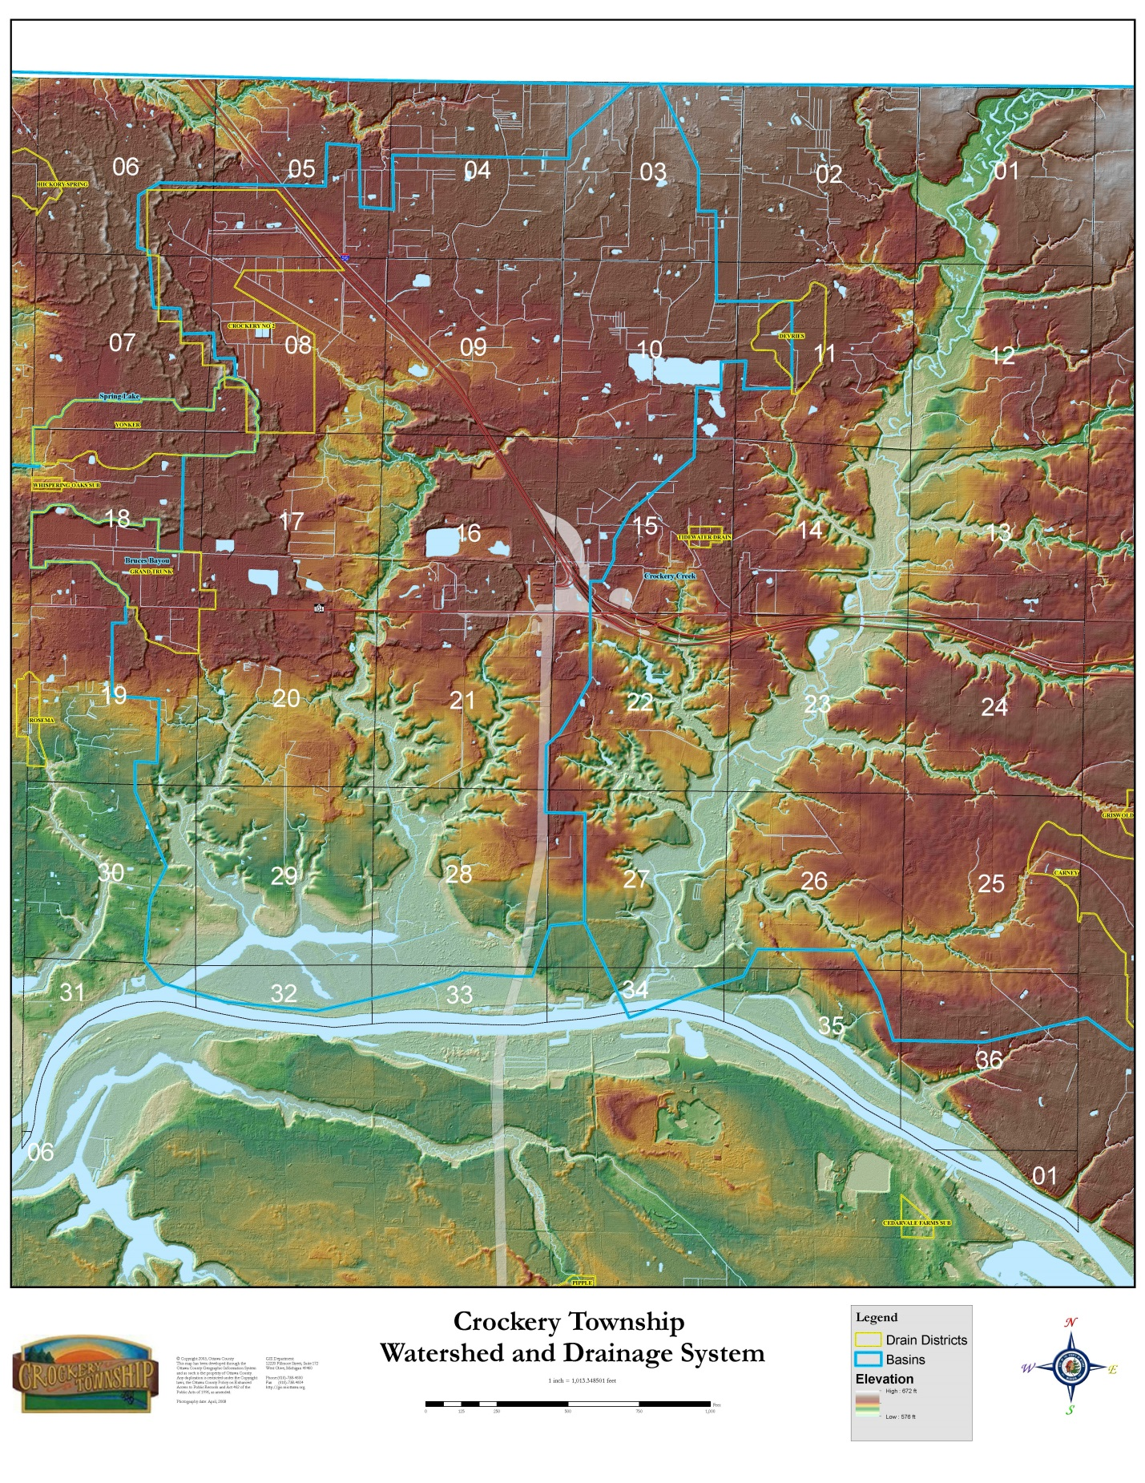
Figure 3
Agricultural Analysis
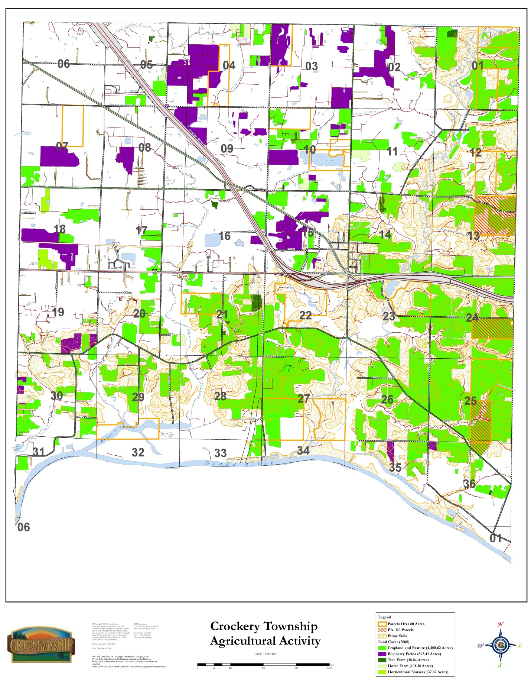
Figure 4
Ground Water
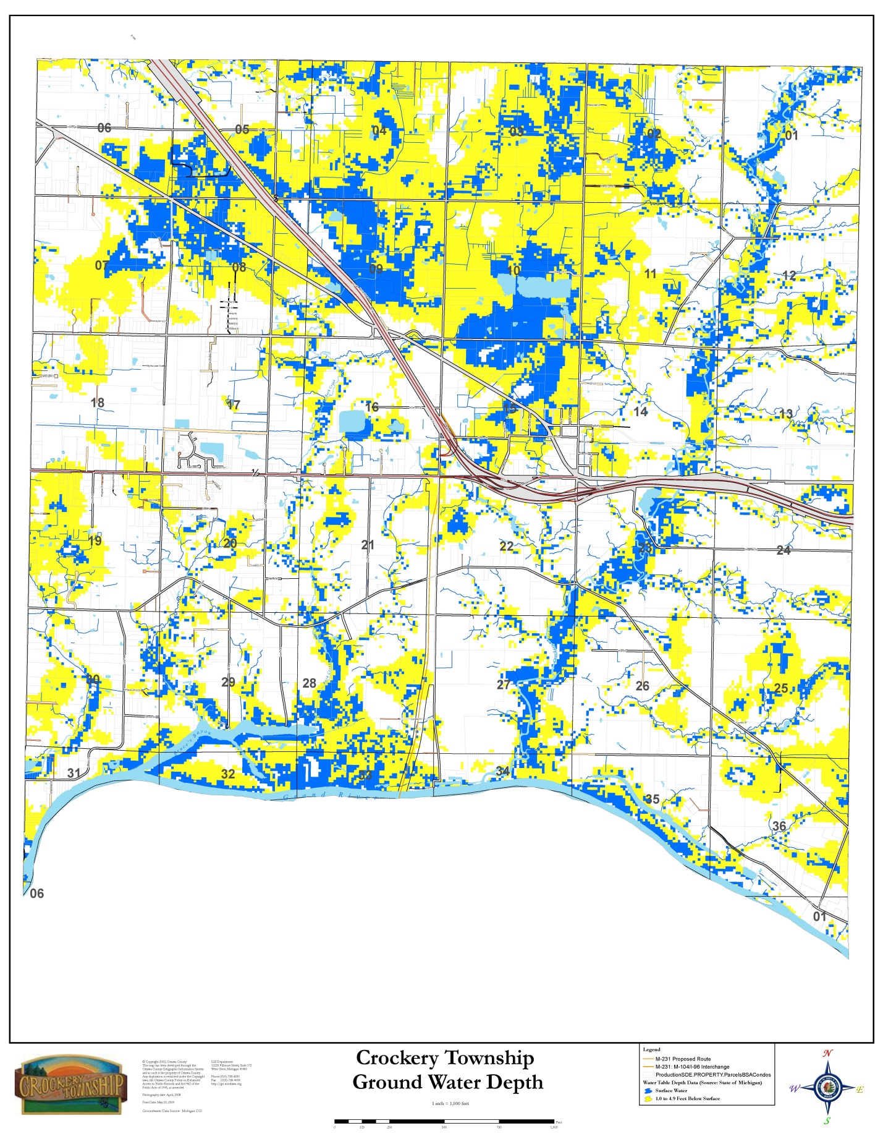
Public Utility Services and Facilities - The Township’s wastewater treatment plant just east of 130th Ave. between M-104 and State Road has been in operation since 2007. This plant has a rated capacity of 150,000 gallons per day and the potential for expansion. Because it is located adjacent to the commercial and industrial zoned areas, it could serve the developing industrial and commercial areas along Cleveland Street (M-104).

The 147-unit Crockery Mobile Home Park on State Road is served by a private wastewater system. Elsewhere, residents and businesses must utilize on-site septic tanks and drain field systems to dispose of wastewater.

The first phase of the extension of the water system into Crockery Township began in 1981 when Crockery Township and Spring Lake Township received a grant to extend water lines from Spring Lake Township into Crockery Township and to construct a distribution system within Crockery Township. The initial phase of construction brought a 12-inch water supply line from Spring Lake Township. The line was extended from Cleveland Street and 144th Avenue north to State Street, east along State Street to 130th Avenue south on 130th Avenue to Cleveland Street, east to 120th Avenue, north on 120th Avenue to Murphy Street and east along Murphy Street into Nunica.

In 1983-1984, additional phases were added to serve residents along 144th Avenue, Walnut Drive, and a portion of Leonard Drive east of 144th Avenue to 138th Avenue, south along 138th Avenue to Garfield Street. An extension of the water main along Garfield Street and thence south along 144th Avenue to the Grand River was approved and fully funded by residents in that area in 1994. All future water supply construction is dependent upon local resident petitions. (See Figure 5 Water System).

Sandy soils, limited aquifer protection and high water tables in the Township continue to make groundwater susceptible to contamination from septic tanks and drain fields. These conditions are likely to increasingly limit the future use of septic tanks and drain fields in many portions of the Township. (See Figure 6 Sanitary Sewer System).

Figure 5
Water System
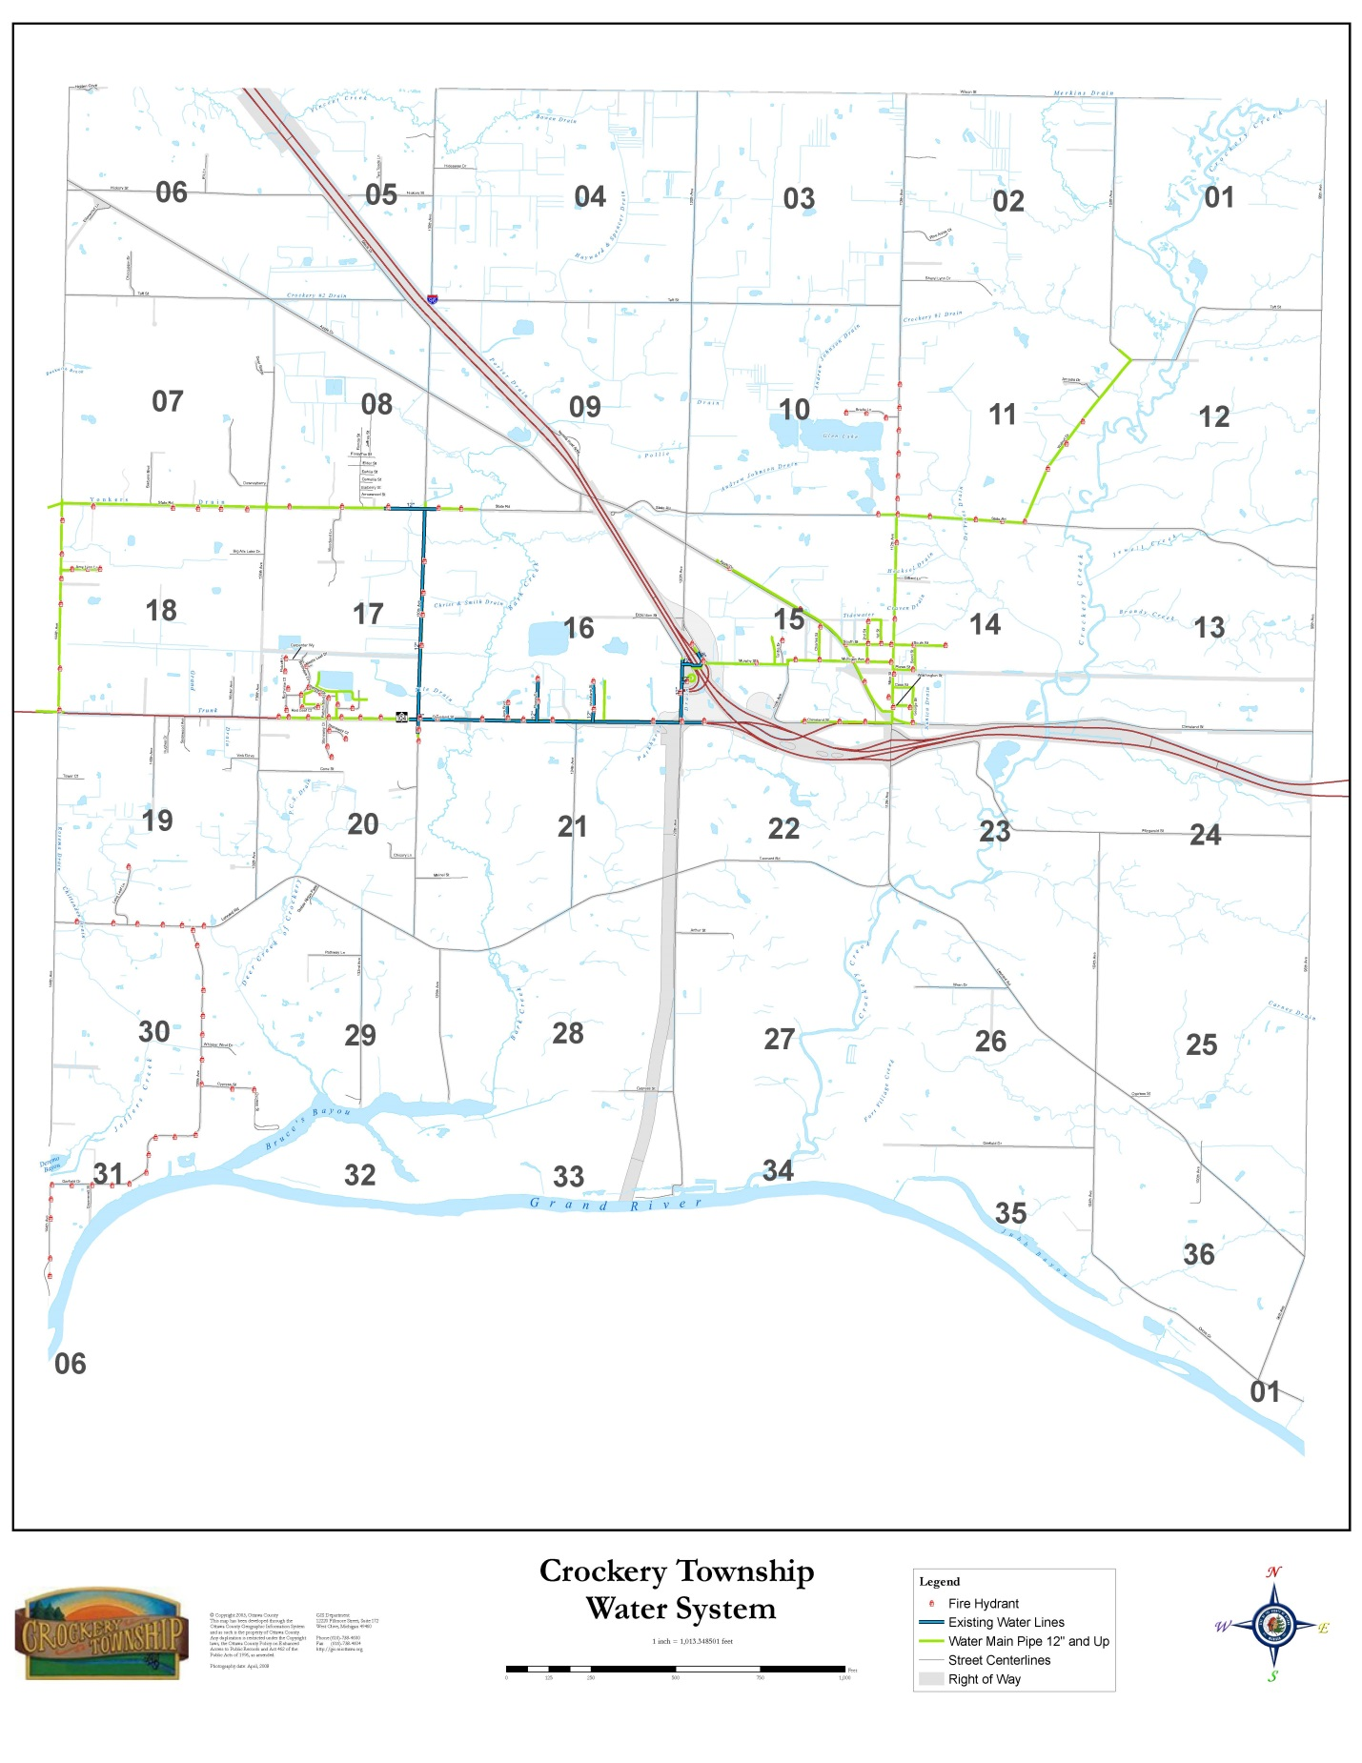
Figure 6
Sanitary Sewer System
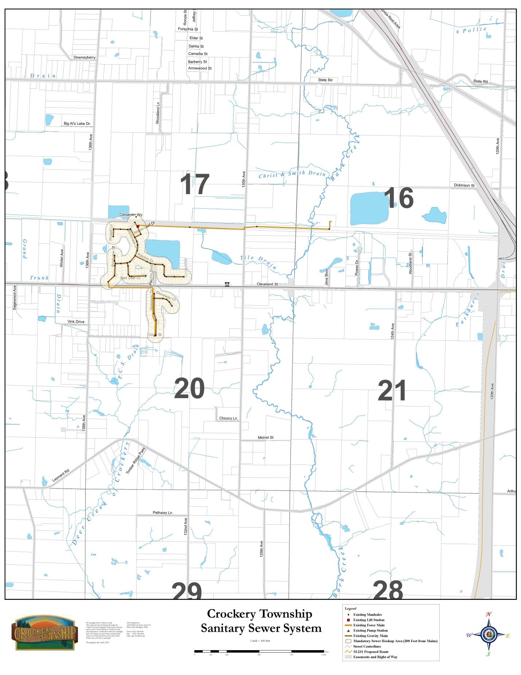
Transportation System - Interstate 96, which travels diagonally (northwest/southeast) through the Township, is maintained by the Michigan Department of Transportation. The average daily traffic volume in 2009 on this highway within the Township was estimated at approximately 32,400 vehicles east of Nunica and 23,200 vehicles per day west of Nunica. M-104 is a two-lane highway connecting the Grand Haven/Spring Lake/Ferrysburg area with I-96 in Crockery Township. It is also maintained by the Michigan Department of Transportation. The average traffic volume on M-104 in 2009 was approximately 17,300 vehicles per day. (See Figure 7 Street and Road Classifications).

Table 1 presents a chart of population in surrounding townships from 1980 to 2010. In 2010, the population according to the U.S. census was 96.4% White. Figure 8 Adjacent Township Growth Rates illustrates growth in surrounding townships between 2000 and 2010.

Table 1
Population in Townships Surrounding Crockery Township
 | 1980 | 1990 | 2000 | 2010
Crockery | 3,536 | 3,599 | 3,782 | 3,960
Fruitport | 11,485 | 12,533 | 12,533 | 13,598
Sullivan | 2,230 | 2,477 | 2,551 | 2,441
Ravenna | 2,354 | 2,856 | 2,942 | 2,905
Spring Lake | 6,857 | 8,214 | 10,626 | 11,977
Polkton | 2,027 | 2,277 | 2,335 | 2,423
Grand Haven | 7,238 | 9,710 | 13,278 | 15,178
Robinson | 3,018 | 3,925 | 5,588 | 6,084
Allendale | 6,080 | 8,022 | 13,042 | 20,708
Figure 7
Street and Road Classifications
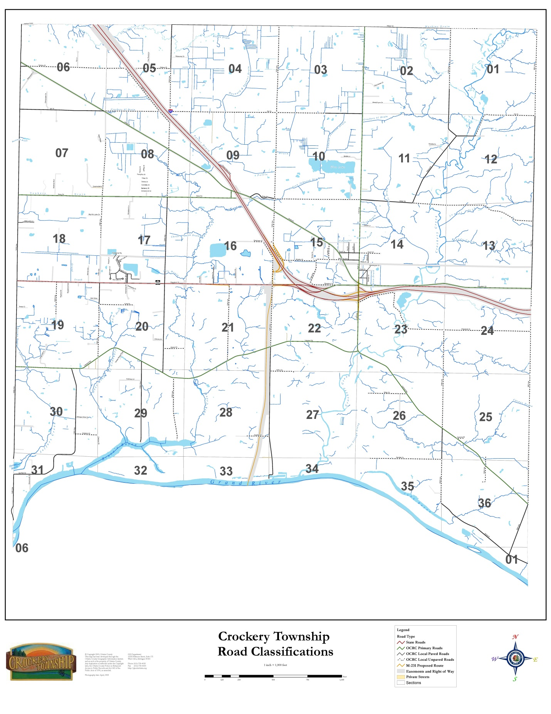
Figure 8
Adjacent Township Growth Rates

Fruitport  13,598  5.3% | Sullivan  2,441  (4.3)% | Ravenna  2,905  (1.3)%
Spring Lake  14,300  12.7% | CROCKERY  3,960  4.7% | Polkton  2,423  3.8%
Grand Haven  15,178  14.3% | Robinson  6,084  8.9% | Allendale  20,708  58.8%
% = Change from 2000 to 2010

Housing - In 2010, there were 1,614 total housing units in Crockery Township with a 6.4% vacancy rate. Of the 1,510 occupied housing units 1,274 were owner occupied and 236 were rental units. In addition, there were about 43 persons living in group-quarters in the Township. The average household size in 2010 was 2.59 persons per dwelling unit. Between 2000 and 2010, the number of year round housing units increased by 166 units or 12%.

The mix of housing in the Township remained rather static, with almost all of the new units being single-family dwellings. The number of mobile homes has declined from approximately 110 in 2000 to approximately 105 in 2010. No new apartment buildings have been constructed in the Township in the last 10 years. Favorable interest rates since the late 1990’s, combined with the recent housing crisis, have encouraged many to improve their homes with additions or other remodeling projects. Table 2 shows the general housing characteristics in the township.

TABLE 2
HOUSING CHARACTERISTICS
2010
 | Number of units | Percent
Total housing units | 1,614 | 100.0
Occupied housing units | 1,510 | 93.6
Households with individuals under 18 years | 483 | 32.0
Households with individuals 65 years and over | 345 | 22.8
Owner-occupied housing units | 1,274 | 84.4
Renter-occupied housing units | 236 | 15.6

Economic Characteristics - A comparison of the income statistics is found in Table 3. In 2010, the median household and the median family income for Crockery Township were $56,000 and $55,095 respectively. These figures are very similar to those of Ottawa County but significantly higher than the State of Michigan. The percentage of persons and families below poverty level was significantly lower in Crockery than Ottawa County and the State of Michigan.

TABLE 3
INCOME AND POVERTY
2000
Category | Crockery Township | Ottawa County | State of Michigan
Median Household Income | $56,000 | $55,095 | $48,432
Median Family Income | $65,403 | $65,474 | $60,341
Per Capital Income | $24,936 | $25,045 | $25,135
Population in Poverty | 3.6% | 5.1% | 10.6%
Source: 2010 U. S. Census

Existing Land Use - Table 4 lists the acreage of various land uses in the township. Table 5 lists the population and housing density in the township and its percentage of the total. A summary of existing land uses in Crockery Township for 2011 is shown in Figure 9.

The categories of existing land use include:

- Residential - Areas and structures for single-family, duplex, multi-family, and mobile home residency are included in this category. Approximately 8,000 acres are devoted to residential use. The highest concentration of residential development is located in the Hathaway Lakes development area. Elsewhere, residential land uses are found in a scattered linear fashion along roadways.

- Commercial - Areas used predominately for the sale of products and services are included in this category. Such uses consume roughly 400 acres. Most are found in Nunica and along Cleveland St. (M-104) just west of I-96.

Table 4
Land Use Acreages
2011
Land Use | Acreage | Percent
Vacant | 7,962 | 39.14
Agricultural | 3,244 | 15.94
Residential | 7,953 | 39.09
Commercial | 406 | 2.00
Industrial | 127 | 0.62
Public/Institutional | 654 | 3.21
TOTAL | 20,346 | 100.00
Source: Ottawa County GIS 2011

Table 5
Population and Housing Density
Population density -------------116 persons per square mile
Housing density-----------------45.1 homes per square mile

- Industrial - Light and heavy manufacturing plants and industrial parks are included in this category. Industrial uses include auto parts, trailer manufacturer, log home manufacturer, coffee roaster, plastics, race engine builder, diesel engine development, two junkyards, and several small, specialized industrial facilities. These plus others collectively occupy approximately 127 acres.

- Agricultural - Within Crockery Township, there are several farming operations. Collectively these farms cover about 3,244 acres of total land. This equates to roughly 16% of the Townships total land area. Of this total, roughly 2,755 acres are in crop land. The major cash crops grown in the Township are corn, hay, soybeans and wheat. Blueberries are the principal fruit.

Figure 9
Existing Land Use
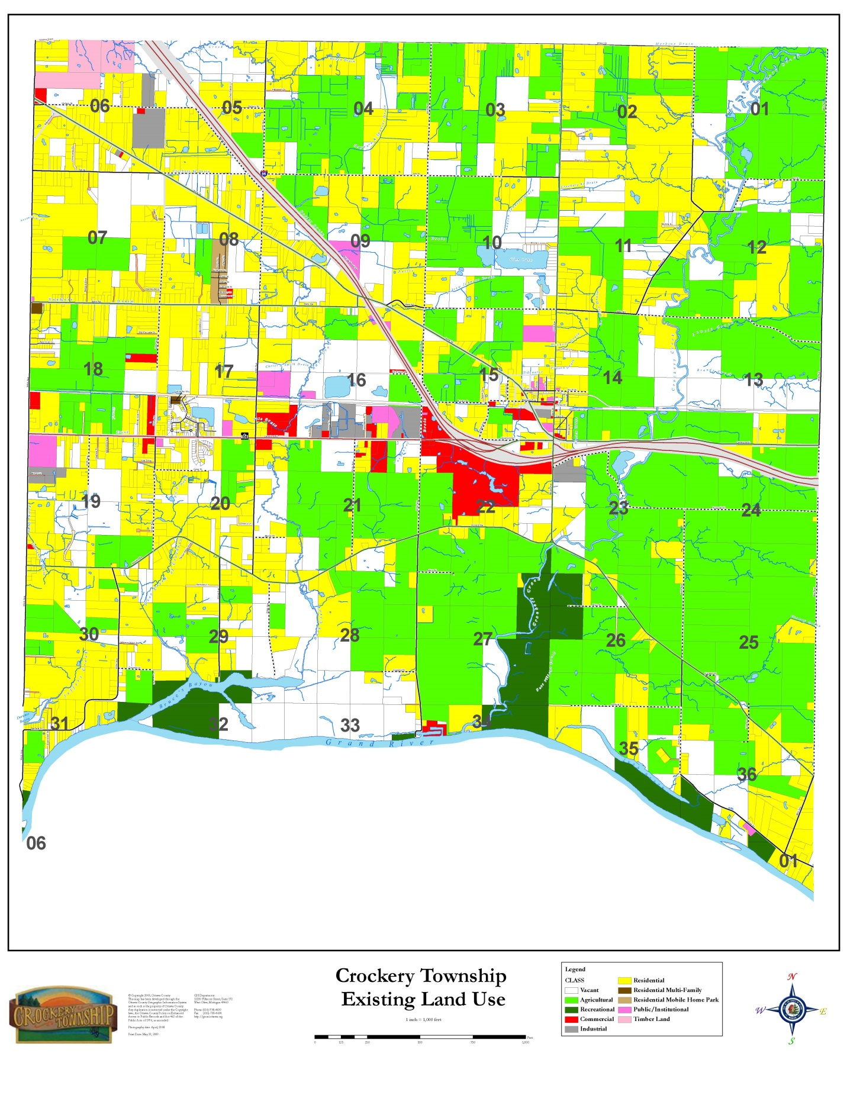
- Woodlands and Open Space - Undeveloped woodlands cover approximately 30 percent of the Township. With the exception of an extensive wooded area in the west central part of the Township, most wooded areas are located in conjunction with the wet soils and steep slopes associated with the drainage network. Open space includes scattered stands of undergrowth, saplings and isolated wetland areas adjacent to streams and creeks. The largest expanses of open space are found in the south central and southeast areas of the Township. Roughly 10% of the Township’s total land area falls in this category.

- Recreation - Recreational lands include both public and private facilities. Among the public recreational facilities are a local Township park facility, and 3 MDNR public boat landings. Ottawa County has purchased large areas of park land along the Grand River and Crockery Creek. Those areas presently remain in an undeveloped state with limited use by the public. Private recreational facilities include a golf course, and an RV campground/trailer park. Recreational lands collectively represent over 500 acres of land.

- Transportation - The amount of land devoted to transportation totals over 1,200 acres. The majority of this is within road and highway rights-of-way. Other related transportation uses include three private airports, power transmission lines, and a gas pipe line substation.

Taken collectively, the existence of very large areas of woodland, agricultural land and open area as well as land devoted to recreation and transportation, account for much of the Township’s total land area. These features give the Township the rural flavor that most residents enjoy.

CHAPTER 3
TRENDS AND REGIONAL ASPECTS

Adjacent township zoning and land use - Land uses in the areas surrounding Crockery Township vary from agricultural, rural residential to commercial and higher density residential, which is reflective of the Township’s diversity in land uses.

Crockery Township’s border with Spring Lake Township is mostly zoned for low density residential (2-acre minimum lot size), Agricultural-2 (10 acre minimum lot size), and medium density (one to two acre minimum lot size) uses. There are commercially zoned properties along 148th Avenue. To the north of Crockery Township is Sullivan Township in Muskegon County, mostly zoned Agricultural-2 (10 acre minimum lot size). The southern portion of the Township borders the Grand River. The eastern Township border is Polkton Township, mostly zoned Agricultural-1 (40 acre minimum lot size).

Population and housing growth trends - Table 6 presents population projections for Crockery Township in five-year increments from 2015 to the year 2035. The projections show a steady, continual population growth. Based on these projections, the Township population is expected to increase by 4.2% percent (163) by the year 2015 and by 5.3% (217) by the year 2020 and 5.3% (229) by 2025. However, these numbers probably do not factor in the new Hathaway Lakes subdivision, so they may be quite conservative.

Full build-out of the new subdivision is expected in approximately 10 years. This subdivision alone will add over 500 new housing units to the 1,614 enumerated in U.S. Census 2010. Therefore, it is reasonable to assume that there will be a surge in population within the next 10 years with approximately 2,100 total housing units in the township by the year 2020.

In addition, the additional population will likely increase the need for commercial establishments the township should expect increasing commercial and industrial development along Cleveland Street. The sewage treatment plant for the new subdivision is positioned so that it could be expanded to serve additional commercial and industrial customers. Construction on the M-231 bypass along 120th Ave. from the Grand River to M-104 and I-96 is scheduled to be completed within the next 5 years.

While we can assume that the population projection will be reasonably correct for 2015. The projections beyond that date need to be revised upward since we can anticipate a surge in population due to the Hathaway Lakes development. With the completion of that subdivision, the population concentration will shift in that direction. The actual population growth could be twice or three times the projections by the West Michigan Regional Planning Commission’s estimate depending on how quickly the new subdivision is built out. It is anticipated that residential growth in the remainder of the township will be confined to no more than 10 to 15 new homes per year. As we have seen in the 2010 Census, each home adds approximately 2.59 persons to the Township population. If we assume that the average number of persons per household over the next ten years is 2.5, the township population should increase by approximately 1,250 by the year 2020.

Table 6
Population Trends
 | 2015 | 2020 | 2025 | 2030 | 2035
Crockery | 4,123 | 4,340 | 4,569 | 4,809 | 5,062
Forecast by the West Michigan Shoreline Regional Development Commission

When population projections are compared with neighboring townships and villages, Spring Lake Township (59.4%) and Robinson Township (92.4%), Crockery’s projected growth rate even with the addition of the big subdivision would fall somewhere between the two. These growth pressures when added to Crockery’s expected population increase affords much attention on Township development limitations (particularly residential sanitary sewage disposal). Population growth has also historically created an increase in local retail and service demands and employment opportunities. The Township must anticipate these demands if it is to maintain the rural setting enjoyed by the most majority of Township residents.

Anticipated Development - Crockery Township is strategically located within an active regional expansion area bounded by Grand Rapids, Holland and the city of Muskegon. This region is named the Grand Rapids MSA (Metropolitan Statistical Area). The newly established M-231 bypass and its intersection with I-96 and M-104 make the Township a potential regional transportation hub. Crockery Township’s proximity to major employment centers within this development area, coupled with its natural resource assets, and quality school systems provide the ingredients for sustainable and increased growth. Retail development is anticipated along the M-104 corridor.

The proximity of larger regional market places creates opportunities for local residents to commute to places of employment. As the Greater Grand Rapids region continues to grow both in terms of employment opportunities and population, the residual impacts of that growth should result in new residential, retail and office development. Recognizing the potential of the local real estate market, the Township should provide appropriate locations for new development. With new travel routes, the Township should accommodate commercial growth and some industrial development.

According to population forecasts it is anticipated that approximately 850 new residents will make their homes in Crockery Township by the year 2030. This population increase would likely create over 340 new homes based on the average household size for Crockery Township, over the next eighteen years. Several residential developments in Crockery Township are continuing, primarily Hathaway Lakes in the central part of the Township.

Community Context - The question is in what context will this new residential development occur? Will it be in the form of large five and ten acre residential parcels, or will it take the form of more traditional higher density development reflected in the newer residential developments and subdivisions along M-104. Similarly, as new residences are built, new retail uses to satisfy the demand for consumer goods would be expected. It is important that the appropriate location and configuration of these retail areas be determined. Ideally, these new developments should be grouped together to provide linkages between non-residential land uses and adjacent residential neighborhoods.

Public Utility Capacity - The public utility network, which determines the intensity of land development and ultimately the pace of development, is generally adequate and has added capacity to serve the Township. While the water and wastewater systems have the ability to serve anticipated development, there are several areas that will require an infusion of public/private funding as development increases. The wastewater system will need to be upgraded along the M-104 corridor to accommodate future growth in the industrial area and potential new commercial developments. The water system must be upgraded to include the construction of a transmission main in several places to accommodate increased reliability in the system.

With infrastructure available to accommodate new growth and development, the Township should guide development into these service areas as much as possible. New subdivisions, site condominiums, and other residential and non-residential projects should be required to locate in areas already served by public water and sewer. This strategy will properly manage growth, ensure that the previous public investment in infrastructure is realized, and assist in reducing urban sprawl normally fueled by leapfrogging developments ahead of the public infrastructure system. It would be advantageous to work with adjacent communities to prepare an intergovernmental infrastructure plan to guide public investment and sub-regional growth.

Regional Real Estate Market - The Grand Rapids MSA is rapidly being viewed as an extension of the Chicago market and the economic hub of Western Michigan. According to recent forecasts this area will become more reliant upon Healthcare and bioscience industry and other developing and expanding technologically advanced industries. These industries are expected to contribute to the overall health of the area. The state of Michigan has plans to invest $2 billion over the next 10 years in the bioscience sector to spur job growth in this market segment. These monies are aimed at life-sciences, advanced automotive in manufacturing, alternative energy and homeland security.

CHAPTER 4
PUBLIC PARTICIPATION

Development Issues and Resource Presenters - In 2010, the Planning Commission conducted a series of resource presentation workshops. During these workshops, presenters representing various organizations, having knowledge of land use issues, were asked to describe what issues in the Township they felt were important to future planning and development.

The presenters identified a variety of issues that might pose limitations to future development such as natural features, utility infrastructure and transportation. Therefore, in the examination of development proposals, limitations to these factors should be considered and protected where it is appropriate. Their focus on natural features included steep slopes, wetlands, soils, ground water and other issues that may make some areas unsuitable for development due to poor drainage. While this is not intended to serve as a tool for rigid enforcement, it does serve as a guide that may draw attention to those areas that may require special attention due to environmental factors. It may not be appropriate to discourage development in these areas all together. Any new development that occurs should exercise caution in protecting these features if natural feature protection and growth is to be realized.

Community Questionnaire – All Township property owners received a postcard inviting them to participate in the on-line survey, and 240 questionnaires were completed. The property owners were asked to describe what characteristics of the Township they believed were “strengths”, and which characteristics they believed were “weaknesses”. The top-ranking characteristics that residents believed were the Township’s greatest strengths were the “quiet rural character and the friendly small town feeling”. The greatest weaknesses seemed to be “lack of local shopping opportunities, road quality, and a lack of public infrastructure”.

Summary of Questionnaire Responses - Overwhelmingly, as might be assumed, 92% of the respondents own land that is their primary residence. Twelve percent own agricultural land. The overlap occurs because people also live on the land they farm. Most people have owned their land for 11 to 30 years. The highest responses for parcel sizes were 1 acre or less and 1 to five acres. Respondents are nearly split on their support for the division of land into smaller parcels. Both drinking water quality and septic systems appear to function very well. In fact, 98% of the respondents in the northeast portion of the Township indicated that their drain field was good. The majority of respondents would be interested in public water and sanitary sewer if it were made available, especially those in the western half of the Township. An overwhelming number (69%) feel that rural character is the primary reason people locate in Crockery.

Bicycle ridership is about evenly split between riders and non-riders, but slightly more than half feel they would use the North Bank Trail. Only 19% utilize the Township Park, and only 10% use the Jubb Bayou Open Space. A higher number (43%) use at least one of the three DNR boat launches on the Grand River and 29% indicated they have used the Crockery Creek Natural Area at the end of Wren Drive. With participation rates fairly low for local recreation opportunities, 64% indicated that the Township should do more to create outdoor recreation like hunting, hiking, biking, etc. Interestingly, only 39% want more traditional activities like tennis, basketball and ball fields, and only 46% feel that the Township should acquire land for future parks and playgrounds. However, 56% of the respondents south of Leonard Road favor acquiring additional land.

Regarding agriculture in the Township, 76% favored zoning techniques to preserve agricultural land, and most also feel that 40 acres was an appropriate minimum parcel size for primary agricultural pursuits. Similarly, for AG-2 zoned areas respondents favored retaining the minimum lot size of 10 acres. A majority also favored special provisions to allow residential dwellings on non-farm portions of agricultural areas. It was felt that in general, 5 to 10 acres was an appropriate parcel size for agriculturally zoned areas. Similar to agricultural preservation techniques, respondents favored zoning controls to protect surface water quality, and protection of ground water quality was considered the most important natural feature.

Most respondents (58%) did not think smaller lots should be allowed to make homes more affordable, however, in the Nunica area 59% do favor smaller lots. They also feel that generally parcel sizes of 2 to 3 acres should be allowed in the rural or low density parts of the Township, however, the majority (52%) also feel that single family homes on large wooded lots of 5 acres or larger are preferred. Clustering lots to preserve open space is not something that respondents believe is a good way to protect the rural feel of the Township. The majority (63%) believe that accessory buildings should be sized proportional to lot sizes. The greatest perceived need for senior housing is considered by 63% of the respondents to be a retirement community. A large percentage (84%), feel that solar panels are appropriate in residential areas.

General issues facing the Township include open space, housing densities, agricultural lands, environmental quality, etc. Based on the responses, the highest priority of all these issues is preserving environmental quality. Next in order of priority is preserving wildlife habitat areas, followed by preserving the small town quality of life and outdoor recreation opportunities.

The highest priority for economic development issues is the need for retail businesses and services in the Nunica area and along M-104 toward Spring Lake. The preferred types of businesses are neighborhood stores, restaurants and grocery stores. Respondents generally do not believe that roads require improvements or pedestrian connectors are necessary and they are not willing to support millage increases to fund such improvements.

CHAPTER 5
PLANNING DIMENSIONS

Planning dimensions are statements which become the basic framework for the development of the Comprehensive Plan. For plans to be meaningful in guiding future growth and development, they must represent the needs and aspirations of the communities’ citizenry and, be realistic within a communities’ financial capability. This is best accomplished through the use of planning dimensions which set forth both the qualitative and quantitative requirements of the community for the planning period.

Planning dimensions include a general growth policy, goals, population projections, and statements about future needs. In preparing these planning dimensions, the Planning Commission has relied on a number of basic studies that provide a factual background relating the past development of the Township. These studies are of value in determining the physical limits and opportunities of future development. All of this data is reflected in the following planning dimensions.

Growth Policy - It is recognized that Crockery Township is an integral part of the northwest Ottawa County area. Intergovernmental relationships include utilities, transportation (including the freeway system and major highways) recreation, and employment centers. Past and future development of the Township has been and will continue to be greatly influenced by these various relationships. The Township therefore realizes that it cannot plan for its future development in complete isolation of the needs and growth trends of the balance of the area. Within this general framework, however, the Township also realizes that it is obligated to plan for its future in accordance with the needs and desires of local residents. The following brief statements represent the overall growth policy based on recognition of both the Township’s area wide responsibilities and responsibilities to the residents and landowners within the Township.

- The Township recognizes that the potential loss of truly valuable farmland and unique natural resources to development is an irreversible loss not only to local residents but the region, state, nation and future generations. It is therefore the intent of Crockery Township to promote the preservation of truly valuable farmland and the conservation of unique natural resource areas such as wetlands and floodplains by directing growth and land uses considered incompatible with these resources to those areas of the Township considered to have a higher sustainability for such development.

- All development should consider the natural capabilities of the land to support the development and the available services and facilities necessary to assure the continued protection of the public health safety and welfare of all Township residents.

Vision Statements -

Crockery Township is a place where open space is valued.
It has the physical beauty of undeveloped lands.
Residents enjoy a rural atmosphere.
People here appreciate the agricultural community.
Residents here value the benefits of hard work, good neighbors, and country living.
While residents recognize that change may be coming they want it controlled.
It is important that Crockery Township have a plan for growth.
The Township needs to insure that infrastructure needs coincide with specific areas of growth and development.

Goal Statements -

Housing – provide environment for investment
Economic Development - provide environment for investment
Circulation – improve quality of roads, sidewalks and trails
Community Services – maintain high level of fire protection services
Community Facilities – expand sanitary sewer and public water services
Community Design and Land Use – encourage creativity in residential areas
Natural Resources – preserve wetlands and floodplains
Cultural and Historic Resources – preserve older buildings
Open Space and Recreation - foster a comprehensive park system
Active Farming – maintain agriculture and the importance of current farming methodology and practices and size of operations

Policy Statements and Planning Goals - Planning goals are statements that express citizens’ values and long range desires for the future development of their community. As such, they provide direction for planning activity.

Planning Goals -

- It is the goal of Crockery Township to encourage the majority of new development to locate in areas where public utilities can be most efficiently provided.

- Maintain the primary residential zoning in the Nunica area, M-104 corridor and in the western 1/3 of the Township.
- Maintain larger parcel sizes in the truly valuable agriculturally zoned areas.
- Encourage the use of Open Space Preservation (clustering) in residential areas

- It is the goal of Crockery Township to accommodate commercial and industrial land uses but limit driveway interfaces in the M-104 (Cleveland St.) corridor.

- Maintain close cooperation with MDOT officials on any development which affects the M-104 corridor.
- Require adjacent property owners to coordinate their plans for development regarding road access.
- Encourage parallel service streets to serve commercial and industrial development along M-104.

- It is the goal of Crockery Township to accommodate a wide range of safe, decent housing in the Township.

- Provide adequately zoned land areas to meet community needs.
- Enforce zoning rules to eliminate rundown and nonconforming dwellings.

- It is the goal of Crockery Township to promote the preservation of unique natural resources and truly valuable agricultural land uses.

- Implement policies in Agricultural areas to discourage residential incursion.
- Preserve truly beneficial agricultural lands.

- It is the goal of Crockery Township to limit development in areas with high water tables or in ecologically sensitive areas.

- Identify those areas with high water tables and retain zoning which would prevent over development.
- Identify ecologically sensitive areas and retain zoning which would limit development.
- Cooperate with the MDEQ, Ottawa County Drain Commissioner, and the MDNR to identify and to limit development in ecologically sensitive areas.
- Protect and preserve existing natural features of the Township

Agricultural Preservation Policy -

- Promote the enrollment of truly valuable agricultural land into the Farmland and Open Space Preservation Act (Michigan Public Act 116).

- Discourage large scale development within areas having truly valuable agricultural land

- Avoid the extension of water and sewer utilities within agricultural areas as a means of discouraging non-farm uses in such areas.

- Discourage the fractionalization of farmland brought about by scattered rural housing development.

- Assess agricultural lands for taxation on the basis of their use as a means of assuring that the value of the land is not artificially inflated thereby promoting the economic viability of farming operations.

- Strive to have all parcels of 10 acres or more acres actively involved in faring be zoned agricultural

- Promote the coordination between zoning and other land use controls relative to farmland and property tax assessing measures.

Residential Land Use Policy -

- Stabilize property values by protecting residential areas from the encroachment of incompatible land uses.

- Allow residential development in exclusive agricultural areas by Special Land Use permit meeting certain non-productive land criteria.

- Discourage the process of scattered, rural housing developments in areas of important and prime farmland.

- Encourage residential development and planned unit developments in areas nearest existing utilities.

- Ensure that the areas intended to support the highest densities of residential development are within reach of existing or planned utility extensions.

- Ensure that the density of all future residential developments that locate in areas that cannot be economically provided with public utilities be limited to take into consideration the natural limitations of the land in terms of the soils ability to accommodate on-site septic systems and the danger of pollution to groundwater supplies.

Commercial Land Use Policy -

- Accommodate a mix of commercial establishments which offer a variety of goods and services to meet the needs of the area’s population while taking advantage of the location of certain areas and their ability to attract tourists and other types of regional trade.

- Encourage pedestrian facilities, sufficient parking and attractive appearances for commercial buildings and properties in the business district.

- Discourage commercial sprawl and strip development.

Industrial Land Use Policy -

- Accommodate the environmentally sound expansion and growth of existing industrial firms.

- Promote concentrated industrial development in those areas in which the provision of appropriate utilities exists, highway access can be made available, and potential environmental degradation and conflict with other uses can be avoided or minimized.

Environmental Policy -

- Promote the conservation and wise use of the Township’s natural resources, including woodlands, water features, wetlands and open spaces.

- Prohibit development in floodplains and discourage development in other environmentally sensitive areas of the Township in order to minimize the potential for property damage and public health hazards.

- Minimize air, water, and noise pollution.

Recreational Facilities Policy-

- Encourage more recreational opportunities utilizing Crockery Creek

- Encourage open space areas and recreational facilities as part of future subdivisions, planned unit development, and other major residential developments.

- Give priority to recreation development in pathways, trails, walking networks and scenic areas.

- Encourage cooperation with other units of government and area schools to develop and expand recreational facilities and programs for public uses.

Transportation Systems Policy-

- Direct the majority of road improvements toward areas where growth is desired.

- Ensure that growth areas are adequately served by access to major collector streets and thoroughfares.

- Direct other road improvements to the worst situations first.

- Assess the traffic impacts of all proposed developments or the location of future streets.

- Limit or discourage dead-end streets

- Ensure the capacity and function of existing roads, minimizing conflicts between through traffic and local traffic by regulating land uses, building setbacks, driveway openings, and where appropriate, encouraging the development of front or rear access service drives.

- Cooperate with the Ottawa County Road Commission and the Michigan Department of Transportation. Crockery Township will encourage these agencies to undertake the necessary studies and to take the necessary steps to ensure that problem areas within their jurisdiction are dealt with in a timely and efficient manner.

Public Utilities, Facilities, and Services Policy -

- Provide the necessary public utilities and services to accommodate the growth of the Township’s population while minimizing costs to the tax payer through proper planning.

- Support the expansion of sanitary sewer and public water within the M-104 Corridor

- Promote the existing Township Hall as the municipal focal point for Township residents.

- Maintain the high caliber of fire protection

- Routinely provide residents with the opportunity for input into the decision making process through public meetings

- Maintain cooperation with neighboring units of government for the provisions of utilities, the sharing of services, and the addressing of common issues and problems as a means of holding down overall costs and expense to the taxpayer while at the same time maintaining local control over the decision making processes.

Rural Character Preservation Policy -

- Promote the use of a Natural Features Overlay to include shorelines, floodplains, bluffs, slopes, archaeological sites, scenic vistas, and biologically significant sites.

- Implement Lighting regulations

- Other than Agricultural activities, limit earth-moving and soil disturbances to no more than one acre without a Special Land Use permit

- Establish a Natural Features Overlay that would include shorelines, floodplains, bluffs, slopes, archaeological sites, scenic vistas, and biologically significant sites.

Natural Resource Protection Policy -

- Purchase of Development Rights (PDR) – Cluster – Permanent conservation land, area based formula, fixed area ratio – large lot (With mandatory clustering only)

- Conventional subdivision or condominium development by PUD or Special Land Use only

- Keep farmland in agricultural zoning districts

- Strive to maintain substantial open space of 65-90% on all open space developments

- Encourage Conservation analysis for land protection regulation and get a land trust involved early on

- Preserve steep slopes, wetlands, floodplains, and prime agricultural land

- Provide Density bonus options in PUD list criteria, trails, linkages, etc.

- Encourage Conservation Easements

- Promote the protection of Crockery Creek to prevent further degradation by working with watershed groups

- Reduce severe sedimentation by working closely with the Drain Commissioner’s office

- Reduce extremes in flow fluctuations

- Preserve buffer strips on agricultural land adjacent to creeks and other surface waters

- Restore and protect agricultural use, water recreation, and public water supply

- Reduce E. coli inputs from septic systems by promoting regular maintenance and inspection of septic systems and expand the use of sanitary sewers in high-risk areas

- Encourage BMP’s in farming operations especially in areas adjacent to Grand River tributaries

- Reduce storm water runoff through site plan review

- Promote guidelines for reporting illicit discharges to appropriate authorities

CHAPTER 6
MANAGEMENT RECOMMENDATIONS

Plan Concepts - The goals and policies previously outlined and analysis of the Township’s physical, social, and economic makeup has allowed the formulation of four broad concepts that will be used in the development of this Plan. These include:

1. Staging of Growth: There is a strong desire on the part of residents to preserve the Township’s rural character and to promote agricultural preservation. In addition, growth trends and population projections indicate that there will be only moderate development pressure in the near term. It is therefore appropriate to establish development priorities for the various land use areas in the community. The staging of development will promote more orderly and concentrated development versus expensive sprawl development.

2. Balanced Residential Character: Varying income levels and life styles of residents, the availability of utilities and physical limitations of the Township, require that a variety of housing densities be provided for. These include rural, rural estate, low and medium to high-density residential uses.

3. Provide for a Variety of Commercial and Industrial Types: Given the Township’s accessibility to regional transportation arteries as well as the employment and shopping needs of local residents, a range of both locally and regionally oriented types of commercial and industrial developments should be provided. To accomplish this, various types of economic incentives to locate in the areas best suited to meet individual business needs should be encouraged. The deliberate and objective allocation of different types of economic development in specific strategic locations will also help to avoid or minimize Future Land Use and traffic conflicts.

4. Protect Environmental Resources: Crockery Township has a variety of environmental resources. These limited features should be protected from development projects and be a part of a project when present. The township should promote the preservation and protection of floodplains, wetlands and ground water by working with the Michigan Department of Natural Resources and/or the enactment of township ordinances addressing these resources.

Providing for Housing Choices - One of the impediments to providing a diversity of housing price ranges is zoning. It is important that the zoning ordinance provide sufficient options of development density to allow residential developers the ability to deliver a variety of housing styles and pricing. Larger lot zoning typically converts into higher land development costs, which is subsequently reflected in the price of the home. However, if developers are able to spread the land development costs over a higher number of housing units, the pricing is reduced. The current Crockery Township Zoning Ordinance includes two Agricultural and two Residential zoning districts that range from one dwelling per 40 acres, one dwelling per 10 acres, one dwelling per 2 acres, to one dwelling per 40,000 square feet.

The residential classifications in the future land use plan have been reorganized to better reflect density and development character. The expansion of the allowable residential densities provides real estate options for working families. It is recommended that the use of Planned Unit Development (PUD) provisions and other innovative land development techniques be employed to achieve a diversity of housing opportunities. Long-range housing forecasts paint a picture much different from today’s perspectives. In a publication entitled, “How Changes in the Nation’s Age and Household Structure Will Reshape Housing Demand in the 21st Century,” published by the Department of Housing and Urban Development in 2003, the character and dynamic of the housing market will reflect more households for singles and families without children. In 1960, 48% of U.S. households had children and in year 2040 this is forecasted to be 27%. Similarly, households without children are forecasted to increase to 30% in year 2040 from a low of 13% in 1960. Household growth between 2000 and 2040 estimates that 87% of new housing units will be without children, and of this amount, 38% will be single-headed households. Another notable trend is the number of persons becoming “senior citizens.” In the year 2000, approximately 400,000 people per year turned 65 years old. The number of persons turning 65 years old is expected to jump to 1,400,000 per year as the “baby-boomer” population curve hits this age cohort. The changing dynamics of the population will have implications at the local level. Population is forecasted to increase significantly in Crockery Township, Ottawa County, the greater Grand Rapids area, and along the I-96 corridor.

The Smart Growth Network, Sustainable Communities, EPA, American Association of Planning, National Housing Builders Association and Urban Land Institute have lobbied the ideas and concepts of “Smart Growth” for more than a decade. In February 2007, the Planning and Zoning Center at Michigan State University unveiled a Michigan Smart Growth program to assist local communities with land use decision-making. These tenets should be implemented, including providing a variety of housing, encouraging mixed uses and promoting compact development.

1) Create a range of housing opportunities and choices
2) Create walkable neighborhoods
3) Encourage community and stakeholder collaboration
4) Foster distinctive, attractive places with a strong sense of place
5) Make development decisions predictable, fair and cost effective
6) Mix land uses
7) Preserve open space, farmland, natural beauty, and critical environmental areas
8) Provide a variety of transportation choices
9) Strengthen and direct development toward existing communities
10) Take advantage of compact building design

They can be achieved by allowing higher density development with opportunities for mixed uses. Compact traditional neighborhoods help address many of the Smart Growth tenets because they employ walkable elements and strategies. Incorporation of Smart Growth concepts and LEED (Leadership in Energy and Environmental Design) Neighborhood (U.S. Green Building Council) rating criteria the revised zoning code would reinforce and help effectuate this public policy.

Connectivity (Linking People and Places) - A highly connected street system linking neighborhoods to schools, retail areas, and community facilities, improves emergency response times and increases the efficient delivery of municipal services. The design of residential neighborhoods has evolved, for better or for worse, from the traditional grid pattern to the curvilinear subdivision. Beginning in the 1930’s, the design of new residential developments incorporated the curvilinear street and the use of the “cul-de-sac” as opposed to the traditional grid pattern. Eighty years later our communities contain large numbers of cloistered neighborhoods with minimal, if any, connections to each other. The result is increased vehicular traffic with its associated congestion and increased car emissions (pollution), greater energy consumption, and reduced pedestrian walking. The contemporary perception is that the use of the cul-de-sac provides a safe haven for children and an exclusive place to reside. In reality, cul-de-sacs create disconnected neighborhoods and reduce the sense of community and place.

Overall, there should be a determined trend to abandon the cul-de-sac in favor of street connections, and attempt to provide connections for cul-de-sacs already in existence. In cases where a proposed subdivision lacks sufficient street connections, a compromise to the outright prohibition of cul-de-sacs could be to require at a minimum the installation of pedestrian connections between developments.

Further, it is suggested that as properties are developed, defined linear parks be incorporated into the subdivision design, providing a pedestrian connection within the context of a broader scope linear greenway. As a means of providing greater seclusion the use of a “commons” to create small neighborhood parks with larger residential setbacks from the street is offered as a design solution. Lastly, the Township is divided by M-104 (east-west), M-231 (north-south) and I-96 (north-south). These physical separations segment the Township into four zones further limiting non-motorized and pedestrian connections. In an effort to mitigate the lack of non-motorized connections throughout the community, the Township should continue support of the community-wide trail and pathway network as the foundation of a walkable community. This network could then connect to a larger regional network.

Parks, Paths, and Trails - Crockery Township is fortunate to have a local and regional biking and walking trail in the Township. The West Michigan Strategic Alliance Green Infrastructure Initiative encourages the establishment of these connector routes. There are also several park and recreation facilities within or adjacent to the Township. Proximity to the Grand River and Lake Michigan coupled with natural areas provide recreation opportunities for residents and visitors. Based on National Recreation and Park standards the Township should have approximately 40 acres of parkland to serve its resident population based on 10 acres of park and open space per 1,000 populations. Although there are several hundred acres of accessible park and open space within the Township, standards would indicate that actual Township ownership of improved parkland is deficient. However, County and State acreages in the Township should be included in this calculation. Recreation facility deficiencies exist primarily at the neighborhood level and not on communitywide basis. It is recommended that new residential development either provides usable open space and parkland or contribute in lieu of actual development to a Township fund for park and open space acquisition.

Regionally, the Green Infrastructure initiative, supports the development of a regional trail system, encourages watershed management and planning, and farmland preservation. All of these areas of concern are key priorities addressed in this plan. The Township should continue its approach as a partner within the region and work with other municipalities on broader matters such as the regional greenway initiative.

The Township could consider a dedicated millage or alternative funding mechanism in order to maintain paved trails within the Township. An improved trail network is part of a broader trail effort being promoted by Ottawa County and the State of Michigan. Crockery Township has been working with other municipalities and the State of Michigan to develop a North Bank Trail extending from Spring Lake to Coopersville along the abandoned railroad right-of-way. Connection of this trail to the new M-231 Bypass trail should be a priority. Continued expansion of the trail network will be an investment in the future of the Township, and strengthen efforts to connect neighborhoods and activity centers. This Comprehensive Plan is not recommending a significant increase of public park and open space acreage, except for the potential acquisition of smaller neighborhood scale park property when it is available, and the procurement or dedication of small parks and plazas along the trail network. Depending on the trail location these areas may include small playgrounds, interpretive areas, or small open spaces. The “Recreational Deficiencies” map designates the locations of the existing and proposed township-wide trail system. It is along these routes that small Township-owned parks could be developed giving pedestrians the opportunity to walk, bike, or jog to these active park areas.

Recreational Development -

- Develop small parks along existing and future trail network
- Continued participation in the North Bank regional trail network
- Create a payment in lieu of parkland for new residential developments to create a Township acquisition fund
- Require sidewalks in all new residential developments

Anticipated Development –

The estimated population increase within the broader “Michigan Corridor” area (I-94 and I-96 corridors between Detroit-Grand Rapids-Niles) is estimated to increase over 1.0 million between 2005 and 2030. In this same time period the number of jobs is forecasted to increase by 1.2 million. As the average household size continues to decline, the number of housing units required to house that population will likely increase. For example, in 1970, the average household size was around 3.2 persons, which equated to 312 housing units per 1,000 people. In 2010, the average household size in Crockery Township was 2.59 persons, which equates to 386 housing units per 1,000 residents. In other words, unless development patterns are adjusted accordingly, more people, living more independently, will continue to consume disproportionately more land.

- 850 new residents by 2030
- Potential for 340 new housing units
- Development likely to occur along M-104 and 112th Avenue corridors
- Forecasted population may demand upwards of 20 acres in commercial, retail, and office acreage
- Wastewater system requires expansion along M-104 corridor to accommodate forecasted development
- Water system requires expansion along M-104 corridor to accommodate forecasted development
- Direct new development to areas with existing public water and sewer systems
- Create higher density zoning districts in areas served by public water and sanitary sewer systems.

Diversity of Housing - Create new residential zoning districts which provide up to 3-5 dwelling units per acre to prevent excessive land consumption

- Establish a stronger sense of place
- Encourage mixed-use development opportunities and provisions in the Zoning Ordinance
- Promote compact design

Commercial Development to Create Space –

- Establish commercial nodes primarily at 124th/M-104 and 112th/Cleveland
- Implement design and land development guidelines for commercial nodes
- Utilize M-104 commercial overlay district at each of these locations to guide development
- Use the commercial nodes as gateways to the Township
- Encourage mixed-use development within the identified commercial nodes

Encouraging Redevelopment –

- Utilize Corridor Improvement Authority to provide infrastructure funding
- Encourage in-fill development when located within public water and sewer services areas.

Residential Development and Densities - A shift in public policy to permit higher residential densities will move Crockery Township toward the vision of a walkable, family-oriented and vibrant community with areas preserved for open space and natural features. Many of the tenets and guidelines associated with Smart Growth programs and the recently released LEED Neighborhood (Leadership in Energy and Environmental Design) rating system promote more compact living adjacent to community and educational facilities within an environmentally sustainable development. Higher density housing goes hand-in-hand with available public water and sanitary sewer systems.

Trends that should be evaluated for incorporation into future zoning regulations include:

- Aging baby boomers want leisure activities.
- People with grown children want to focus on themselves and not the maintenance of a home (empty nesters). Low maintenance housing is generally characterized as a condo community or a Planned Unit Development.
- Housing options for seniors need to be readily available and affordable. The housing options can vary from simply an independent retirement community with similar age groups, assisted care units, to complete care facilities. The key goal of these housing options needs to encompass the idea of non-exclusion from the rest of the surrounding community. Potential expansion of the sanitary sewer system increases the locational opportunities for multi-family housing including senior citizen facilities.
- Senior housing options providing easy access to major services such as health care, transportation options, recreation facilities, community centers, public utilities and in close proximity to a centralized area creating a sense of connection to the community is vital.
- Communities that provide “life cycle” housing opportunities have stronger social networks and give aging residents the opportunity to live near families and friends.
- Many “active adults” characterized mostly by retirees, but not always, enjoy communities where others share common interests, such as walking/jogging trails, golf courses and waterfronts. Active adults are attracted to these communities because their former larger homes were too much work for their active lifestyles (large yards, general upkeep of a large home). Smaller, low maintenance homes make it easier for active adults to enjoy their lifestyle choices.
- The trend of less people per household results in diminished need for large homes, and smaller homes on shared lots usually require less maintenance for the upkeep of the exterior areas.
- Many people consider a close-knit community as the main focus in purchasing a home.
- People with children may consider the availability of a wide variety of diverse activities to be advantageous. New residential developments should be located in a centralized area that is accessible to all families and located near existing schools to promote walking. Residential developments should also be near park and recreation facilities, and if possible, libraries and community centers to promote continuous education and creative activities.
- Compact development decreases site development costs, which positively affects housing costs and maximizes the public investment in capital infrastructure.
- Natural features such as wetlands and woodlots can be better preserved when developers are offered the ability to cluster and create compact development designed “with nature.”

The Mixed-Use Zoning District Option - The Mixed-use District would provide the Township and developers the opportunity to create traditional residential neighborhoods with higher dwelling unit densities than currently allowed. These mixed-use districts would allow landowners and developers the opportunity to submit project densities ranging from 5 to 9 units per acre. Other elements of this district include the opportunity for mixed-use development, varying residential lot sizes, and “life cycle” housing. Requirements associated with this district include regulations of building and site design, availability of public utilities, connection to the Township trail network, and dedication of public open space. The principle tenet of this district is innovation and flexibility.

Recreation Areas - The Township should initiate a concerted effort to secure properties suitable for future recreation or open space to serve an ever-growing population. Areas where land should be acquired for future parks and recreation are identified in the illustration denoting “Recreation Deficiency Areas” [from recreation plan]. These recreation areas were identified after reviewing the location and density of children under the age of fifteen, and areas, which are currently undeveloped and will likely be developed into residential neighborhoods. These new park facilities should be designed to provide adequate and useable open space for neighborhood residents, and be within ½ mile of 90% of the resident population base. When opportunities arise to purchase riparian property with access to the Grand River, Crockery Creek or tributaries, the Township should utilize applicable federal and state grant programs to assist with the acquisition. The map on the adjacent page shows the location of Recreation Deficiency Areas in the Township. (See Figure 10 Recreational Facilities)

Open Space Preservation - Crockery Township should reserve the option to preserve lands that contain fragile natural features such as wetlands, and flood plains. Open space areas for passive recreation can be valuable especially in areas near the existing and proposed non-motorized trails throughout the Township. Preservation of open space can be achieved through regulatory and/or financial incentives. Regulatory incentives could include purchase of development rights (PDR’s), and via conservation subdivisions and/or cluster housing. Conservation subdivisions allow the property owner to maintain the same build-out potential of a piece of property by developing the units on smaller more compact lots and dedicating the balance of the property as open space. A financial incentive used by property owners desirous of preserving natural features and open space on their property is the use of a conservation easement through a land conservancy, such as the Land Conservancy of West Michigan. Property can either be acquired through the organization or gifted whereby the property owner receives certain tax write-offs.

Rural Preservation Routes - Preserving and enhancing the rural character of Leonard Road is recommended as representing the rural character of the Township. Preservation of this route would be done through a Rural Route Preservation Overlay District. This district would include guidelines for building setbacks from the road right of way and landscaping requirements as well
Figure 10
Recreational Facilities
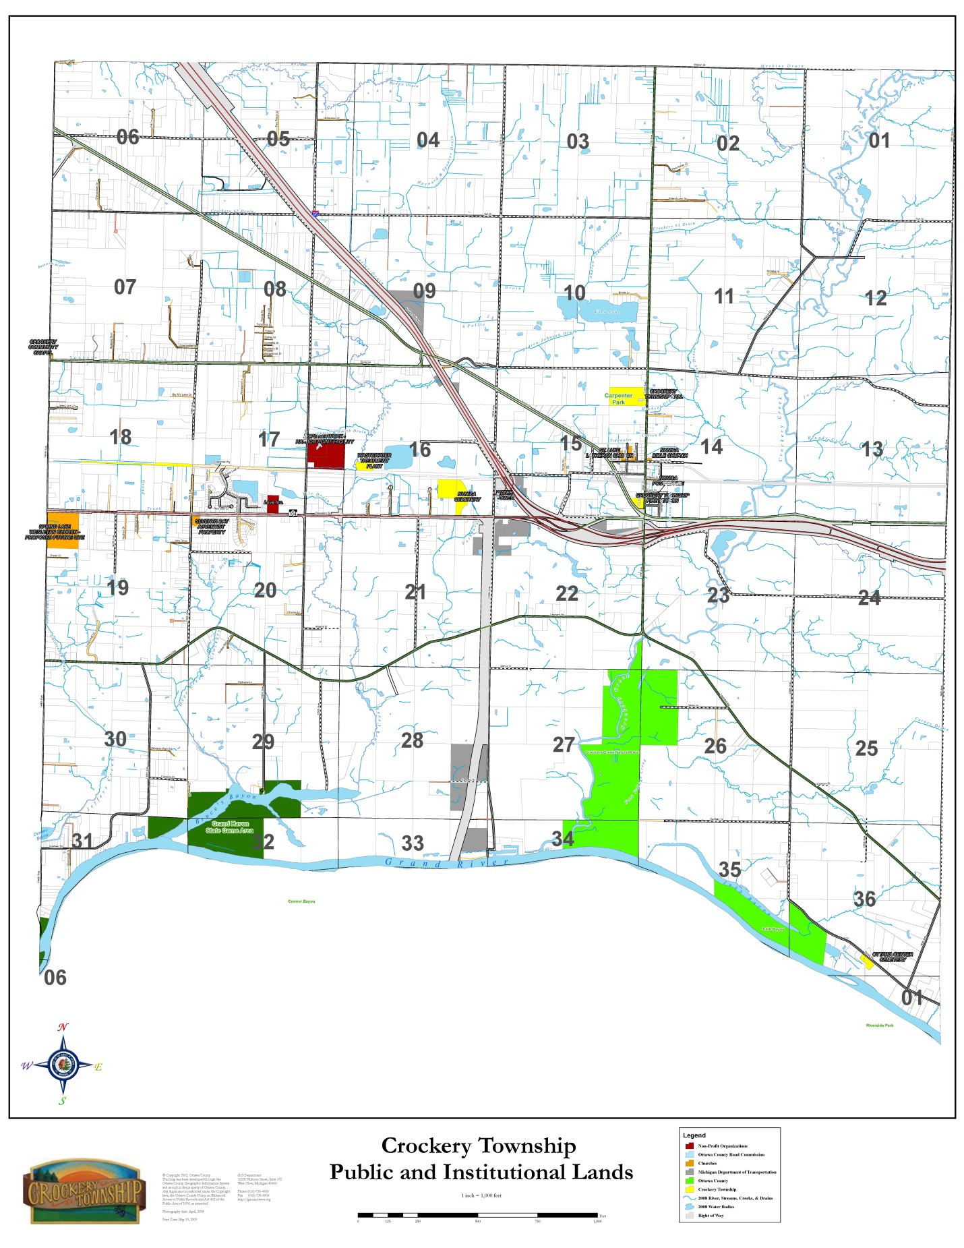
as guidelines for signage and lighting. The Township should coordinate efforts with the Ottawa County Road Commission and utility companies to preserve landmark canopy trees along this route. When trees are removed for utility access, Crockery Township may consider opportunities to replant with “utility friendly trees,” such as Dogwoods. Maintenance and pruning of the right-of-way and road front is a key component to enhance this type of overlay corridor.

This overlay designation would preserve significant vegetation in an area 35’-50’ outside of the right-of-way. Using this overlay district as a preservation tool would help the Township meet its objective to maintain the rural elements of the community.

Road Connections - The Township is served by a network of principle and minor arterials including I-96, Cleveland Street (M-104), 144th, 112th, Leonard Road, and Apple Drive. Other important cross Township roads include Wilson, Taft, State, 130th and 136th. As new development occurs, the Township should plan for an interconnected road system to maintain efficient traffic flow. Except for situations where there is extreme site topography and/or natural features, the extended use of cul-de-sacs should be limited in favor of a more traditional and functional network. Potential locations for new road connections to access to land-locked parcels and/or increase connections between existing roadway segments should be identified. The construction of these new road segments should be accomplished as part of the land development process by the developer, with an emphasis on further development of cross Township routes. It is recommended that new road segments providing network connections to other public roads are dedicated as public right-of-way. In addition, rear access drives parallel to M-104 is an obvious example of network road connections.

Corridor Access Management and Corridor Improvement Authority - When development occurs haphazardly along a transportation corridor, the result is usually less than desirable. Unplanned development often leads to traffic congestion and the typical “strip commercial” appearance currently seen along many state and county roads. The continued use of the M-104 Corridor Overlay Zoning District utilizing access management techniques to regulate site access improvements is recommended. In addition, future corridor development will require public and private funding to improve infrastructure, remove and/or remediate blighted properties, and create a favorable investment environment. The Corridor Improvement Authority (CIA) district is the ideal tool to accomplish many of these objectives. This authority was established by the Township Board in 2011 and provides the community the opportunity to guide and redevelop these areas using tax increment financing.

Proposed Commercial Development - Given the Township’s accessibility to regional transportation arteries as well as the employment in shopping needs of local residents, a range of both locally and regionally oriented types of commercial and industrial developments should be provided for. To accomplish this, various types of economic developments must be encouraged in areas best suited to meet individual business needs. The deliberate and objective allocation of different types of economic development in specific strategic locations will also help to avoid or minimize potential land use and traffic conflicts.

Many residents of Crockery Township consider Nunica the center of the Township but depend on Spring Lake, Grand Haven, Muskegon and Grand Rapids for shopping and social experiences. Many residents take the view that the M-104 commercial corridor in the township is potentially the de facto downtown but unusable until more is offered. The issue confronting the community is how M-104 (Cleveland Street) and 112th Avenue will be developed. Currently, the Township Zoning Ordinance indicates that frontage along these corridors will be primarily commercially developed, with some industrial development.

Along M-104, access management is achieved through a combination of appropriate site design and land use planning. From a traffic management viewpoint concentrating similar uses is preferred over elongating and spreading the same building mass and usage over a lengthy distance. From a land use perspective concentrating a similar mix of land uses in concentrated nodes creates economically viable and sustainable centers. It is recommended that proposed commercial nodes be limited to the following:

• 112th Avenue and Cleveland Street intersection: 10-14 acres
• M-231 and M-104 intersection: 20-30 acres
• 124th Avenue and M-104 intersection: 10-14 acres
• 136th Avenue and M-104 intersection: 5-10 acres
• Nunica: 10-20 acres

Commercial development at the 112th Avenue and Cleveland Street intersection could be distributed to all four corners and extend about 1,000 feet east and 2,000 feet west along Cleveland Street, and 1,000 feet south to the south side of the I-96 Expressway. The Future land Use map illustrates this type of commercial development.

The commercial development at the M-231 intersection would be relegated in the short-term to the northeast and southwest corners side of the intersection. The primary gateways to the Township will be the I-96 and 112th Avenue interchange, and the M-231 and M-104 intersection. As a result, this commercial area should be managed with design guidelines focusing on building materials, signage (ground and projecting), landscaping, rear and side parking lots, pedestrian walkways and amenities. Eventually, the Township may want to consider specific standards for facades including such items as the amount and placement of brick, glass, etc. The area should have the appeal of traditional and walkable commercial districts and not a suburban strip center. The variety of uses within these centers would include restaurants (sit down and drive-through), fuel stations, taverns, banks, convenience centers, retail and service businesses, and professional services. Elimination of outdoor storage and aggregate stockpiling should be an immediate priority. Implementation of the commercial node concept will require a change in zoning to provide land development and building design guidelines.

The commercial nodes can become the cornerstone for mixed-use walkable neighborhoods. Each proposed mixed-use area could include higher density residential (5-7 dwellings per acre) developments supplemented with parks, community facilities, such as schools, and commercial areas. In some communities, the development of “lifestyle” centers assumes this role. However, the retail element in these developments can exceed several hundred thousand square feet of leasable area and are occupied by national retail chains. The proposed mixed-use areas for Crockery Township envision less of an integrated development and more of a collection of independent developments constructed under a consistent set of land and building regulations. The use of the M-104 overlay zoning district coupled with specific design guidelines is recommended. This combination of land uses linked together with design and land development standards will establish a definable place. Commercial nodes should be considered pedestrian-oriented commercial districts reflecting the scale and diversity often associated with downtown areas. Buildings would be located near the property lines with parking preferably in the rear or along the side of the buildings using pedestrian scale streetscapes. Commercial areas outside of the nodes would be vehicular-oriented commercial districts accommodating banks, dry-cleaners, auto related businesses, professional offices, and errand-based service businesses.

Commercial Nodes versus Sprawl - Commercial Development Nodes are identified at several intersections along M-104 and 112th Avenue. These nodes effectively compartmentalize commercial development into key intersections of the Township and create commercial and mixed-use development areas. These commercial nodes are located near existing residential areas and serve the day-to-day needs of residents including gas stations, restaurants, grocers, café’s, dry cleaners and other services needed on a regular basis. Adjacent higher residential densities may be desirable to make these compact commercial areas viable. To accommodate this higher density, the Township will have to provide public water and sanitary sewer facilities. The strategy of using commercial development nodes should significantly reduce commercial sprawl in the Township and consolidate commercial development into integrated and definable sites. Future benefits of this form of development include a reduction in traffic congestion, more efficient traffic movement, less negative air quality impact, and enhanced opportunities for walkable and non-motorized connections. Another feature associated with this form of land development is the ability to create a definable place and in the case of the 112th Avenue and Cleveland Street intersection a gateway into the community. When planned in conjunction with existing or new residential development these commercial districts become focal areas for community events such as festivals, farmer markets, activity centers, and places for entertainment.

Business and Industry - The intersection of I-96, M-231 and M-104 is expected to increase the demand for business development. The Township should support businesses that sustain a strong work force and stable tax base for the Township. By introducing higher density residential near these employment centers the Township hopes to provide employees of these business centers the opportunity to own a home within an easy commute and/or walking distance to destinations of employment. Access to abundant recreation opportunities, trails and natural features such as the Grand River and proximity to Lake Michigan provide incentives for new businesses to take advantage of these amenities. The Township has a variety of industrial land uses and buildings on the north side of M-104, and the scattered light industrial properties along 112th and Apple Drive. The Township should undertake an inventory of industrial developed and vacant properties to assess their economic development potential. More acreage north of M-104 can be made developable for industry by providing public water and sanitary sewer facilities.

Community Gateways - Gateways into the Township currently do not effectively announce arrival and communicate the sense of pride and the character that is Crockery Township. Opportunities exist to develop primary gateway entrances into the Township primarily along M-104 at the I-96/M-231 intersection area and in the Nunica area. These entrances can use a variety of features including landscaping, signage and lighting to define the edge of the community and develop a strong identity for the Township.

Interchange Image - Crockery Township has two locations on I-96 to establish an image and greet visitors to the community and these occur at the interchange with M-104/M-231 and the interchange at 112th Avenue. It is recommended that these zones be visually and aesthetically improved with wayfinding signage and improved streetscaping. Although both interchanges provide access to the Township, the M-104/M-231 interchange will be the most significant for visitors from the south and north, and the interchange at 112th Avenue will be the gateway from the east. Both will require significant planning and guided development.

Wetland Management - There are federal and state programs that protect wetland areas through both acquisition and regulation. The Michigan Department of Environmental Quality (MDEQ) administers the Natural Resources and Environmental Protection Act of 1994, Act 451. The U.S. Army Corps of Engineers regulates fill activities in wetlands areas adjacent to the Great Lakes, pursuant to the Clean Water Act, fill, and dredge activities in navigable waters of the U.S. pursuant to Section 10 of the Rivers and Harbors Act. The Michigan DEQ coordinates permitting through a joint process for wetlands that fall under mutual jurisdiction.

Local communities are authorized to enact local wetland ordinances to fill the gaps in state and federal legislation and exemptions. The Wetlands Protection Section of Act 451 states that local governments can adopt more restrictive regulations for wetlands than contained in the act.

Some principal objectives of local wetland regulations are to:

- Prevent filling, dredging, alteration, or removal of material from a wetland area
- Prevent alteration to drainage patterns that may affect a wetlands system
- Provide a protective, natural greenbelt around wetlands
- Prohibit deposition of any material - including hazardous chemicals, non-biodegradable aquatic pesticides, herbicides and fertilizers - into, within or upon the wetland or the greenbelt buffer area adjacent to a water body or wetland area.

Floodplain Management - Floodplains are susceptible to flooding due to their relatively low-lying topography. Floodplain regulations seek to modify the susceptibility to flood damage and disruption by avoiding dangerous, uneconomic, undesirable, or unwise use of the floodplain.

The most widespread floodplain regulations are the minimum requirements of the National Flood Insurance Program, which must be enacted and enforced by communities participating in the program. The minimum regulations vary depending upon the risk of flooding as determined by studies and mapping that has been done in a community. Minimum regulations may include:

- Permitting for all proposed development
- Reviewing subdivision proposals to assure that they will minimize flood damage
- Anchoring and flood proofing structures to be built in known flood prone areas
- Safeguarding new water and sewage systems and utilities from flooding
- Enforcing risk zone, base flood elevation, and floodway requirements after the flood insurance map for the area becomes effective.

Development Staging - The demand for additional developable land and demands for utilities and other public services go hand in hand. Because of this, a major objective of the Comprehensive Plan is to direct development into areas best able to support it and conversely to delineate the areas that are not suited for major development within the planning period. To promote the efficient provisions of public services, maintain rural character and to control sprawl development situations, it is necessary that the highest densities of future development be encouraged to locate within areas (1) already served by utility services, or (2) can be expanded to accommodate, or (3) which are capable of being economically served. To that end, it is important that rezoning and the extension of utility services necessary to support new development be incremental, based on need, and cost feasibility.

In consideration of the anticipated practical limits of utility and public services, future highway improvements, existing development patterns, anticipated land needs and the goal to conserve and preserve certain natural elements, the boundary of the Agricultural 2 District represents the approximate maximum extent to which urban types of services and/or development and/or the extension of public utilities within or in close proximity of this boundary should be avoided until such time that it becomes apparent that the demands for additional land can no longer be met within the other planning districts.

Another feature of the development staging plan is the delineation of lands which for environmental reasons should by in large be left in a natural or semi-natural state. Therefore, the Agricultural designation has also been assigned to the floodplains of the Grand River and Crockery Creek. These areas should support only the least intensive types of development activity such as very low density residential, various recreational types of uses, farming (when properly practiced), and natural wildlife habitat. Intended as an overlay district, the primary objectives of this Floodplain District is the prevention of economic and environmental damages due to flooding or intensive developmental patterns, the preservation of the value and character of the river and the protection of local flood retention and runoff capability. Other major objectives are the preservation of fishing, wildlife habitat, water quality, and scenic and aesthetic qualities.

The preservation of natural resources is one of the many goals of the Township. As such, all developments should be designed to work with the natural resources. The environment should be viewed as a limited commodity which took decades to create. Many of the natural resources have been documented by various studies, and state and federal departments. This material and data should become part of the Township’s database in reviewing new development proposals.

Clustering/Open Space Development - This technique provides for the clustering of dwellings (within a residential development) on lots smaller than those normally allowed under existing zoning, usually with the provision that the land that is saved be set aside permanently as open space. This technique encourages grouping dwellings in those areas of a development site that are best suited for development.

Cluster subdivisions generally conform to a zoning districts “gross density” requirement (measured by the number of dwellings per acre relative to the total area of the site). Clustering may increase the site's "net density" (measured by the number of housing units per acre relative to the buildable area of the site), by reducing lot sizes and concentrating development on a smaller portion of the available site.

Open space/cluster option provisions are becoming more common in zoning ordinances as a means of varying the usual pattern of development. Clustering/open space development is known under a variety of names such as “Open Space Development”, “Clustering or Cluster Development”, “Conservation Development”, “Open Space Zoning”, or “Rural Clustering”.

The object of clustering is not to increase the development density permitted by the individual district, unless incentives are provided to do so, but to limit the amount of land disturbed by structures, lawns, and drives. The gross density must still fall into the requirements of the Zoning Ordinance. It allows only that the development that would be permitted under conventional zoning regulations, but allows that development to be placed on a smaller portion of a site. Often large parts of a site are permanently protected open space, protected by a restoration covenant or, in some instances, deeded to a non-profit land trust or the township. Changes in zoning should only be considered only after public water and sewer services are in place.

This technique generally applies to developments that contain unique natural or cultural features, such as wetlands, floodplain, mature trees, steep slopes or significant historical features. Density bonuses may be granted in order to encourage this type of development, but are not necessarily needed since clustering can reduce a developer's construction costs for road paving, grading, etc.

In Michigan, this technique is required by Act No. 110 of the Public Acts of 2006, known as the "Michigan zoning enabling act". The Act states that the township must provide in its zoning ordinance that land zoned for residential development may be developed, at the option of the landowner, with the same number of dwelling units on a smaller portion of the land than specified in the zoning ordinance, but not more than 50%, that could otherwise be developed, as determined by the local unit of government, if all of the following apply:

- The land is zoned at a density equivalent to two or fewer dwelling units per acre or, if the land is served by a public sewer system, three or fewer dwelling units per acre.

- A percentage of the land area specified in the zoning ordinance, but not less than 50%, will remain perpetually in an undeveloped state by means of a conservation easement, plat dedication, restrictive covenant, or other legal means that runs with the land, as prescribed by the zoning ordinance.

- The development does not depend upon the extension of a public sewer or public water supply system, unless development of the land without the exercise of the option provided by this subsection would also depend upon the extension.

- The option provided under this subsection has not previously been exercised with respect to that land.

- After a landowner exercises this option, the land may be rezoned accordingly.

Lot Averaging/Lot Sizes - Lot averaging permits one or more lots in a subdivision to be undersized, providing an equal or greater number of lots in the same subdivision is oversized. Lot averaging is a technique that has been frequently overlooked as communities adopt more sophisticated cluster or open space development regulations. However, it can be used as a "scaled down" version of clustering to address situations that may not warrant requiring the submission of more extensive cluster plans.

Lot averaging has particular applicability to headwaters areas, especially in communities with large lot zones. Lot averaging is a technique that may be used with land divisions in order to offer a more simplified version of clustering. Allowing lot sizes to be averaged over an entire site offers flexibility to adjust lot sizes where resource protection goals are met. Providing the incentive of downsizing certain lots should be coupled with certain requirements for open space protection.

Planned Unit Development - Planned Unit Development (PUD) regulations give developers an increased level of flexibility in the overall design of residential projects in exchange for a higher quality of development. The PUD process offers greater latitude in locating project elements on the development site. PUD elements can include housing, streets, open space, recreation areas, buildings, mixing various housing types and densities (single- and multi-family), and land uses (including some neighborhood commercial uses), and commercial/office uses into a functional unit that is integrated with the natural features of the site, and in some cases grant density increases over those normally allowed in the zoning ordinance. PUDs are generally characterized by:

- Flexible zoning standards (lot size, setbacks, street frontage, etc.)
- Focus on overall project design rather than traditional lot-by-lot zoning
- Encouragement of innovative site design and housing types
- Provision for on-site amenities (e.g., open space and recreational facilities)

PUDs may be regulated as:

- Separate zoning districts
- Special land uses permitted in selected districts
- "Floating zones" which do not apply to a particular location until an application is received and approved
- Designated overlay zones in addition to any zoning district

PUD’s allow for developer creativity while meeting overall density and land use goals. PUD’s can allow for a mix of land uses, reduction of lot size, increase in height, or other waivers from conventional zoning regulations in exchange for some public benefit. PUD’s have been used to promote environmental preservation, preserve open space, natural features, and other community goals. It enables local municipalities to negotiate with developers in order to create a compatible relationship between the built and natural environment.

Communities should be careful to avoid an overly cumbersome PUD process, which may discourage developers from using this alternative. Flexibility is a major key to successful PUD projects. Creating incentives such as reducing minimum land area requirements for PUD’s can encourage greater use of this development technique.

Development Agreements - Development agreements can be used to restrict some future uses of property, and are generally developed prior to the approval of a site plan. Development agreements ensure that ordinance requirements and other mutually agreed-upon items are enforced and may include the following: architectural character, maintenance agreements, and other natural and built environmental issues. Development agreements may also be associated with subdivisions and site condominium developments which require formal recording of the agreed upon issues within deed restrictions. Development agreements are legally enforceable only by the local municipality.

Site condominium and subdivision development agreements/deed restrictions may include any reasonable restrictions, along with others that may be part of the development approval process.

Hazard Mitigation – The Township should give consideration to hazard mitigation needs and concepts. Having hazard related strategies in place can help mitigate a variety of potential threats. The Township should consider:

- Emergency Notification System – Develop actions to strengthen and maintain emergency notification systems and coordinate as needed to bolster the dependability of emergency communication systems.
- Severe Weather Preparedness – Address warning system needs in the Township by replacing the existing outdoor warning siren at the Fire Station and placing additional warning sirens at population centers.
- Infrastructure Strengthening - Identify potential improvements or projects to strengthen the area’s infrastructure to increase hazard resistance.
- Fire Preparedness – Consideration of additional fire related public awareness and training activities. Assess and/or address any possible shortfalls in fire mitigation actions, regulations, supplies, firebreaks, staffing, and risk assessment details.
- Fire Response – Access to the southeast corner of the Township can be frequently cut off by spring flooding. Also, the single lane bridge on State Road sees frequent flooding.

CHAPTER 7
LAND USE NEEDS

Residential - The addition of another 450 housing units at the Hathaway Lakes and Cobblestone developments over the next several years should satisfy most of the need for additional housing in the township. The mix of single-family dwellings, two-family dwellings, and condominiums in the development should provide the diversity demanded by the buying public. Other single family residential development will most likely be located on vacant parcels and land divisions, mainly in the R-1 and R-2 zoning districts. It is expected that throughout the Township there will be mostly single-family homes as opposed to other types of housing.

The Township has a large number of private streets serving small developments generally from two to ten dwellings. In the future, private streets should be allowed under circumstances whereby they could potentially create connections with other private or public streets. It is possible to require that private streets be allowed only when using the cluster option. Otherwise, subdivisions and site condominiums, especially those having more than thirty lots, should be required to have public streets.

Currently, there are just two residential zoning districts that accommodate parcel sizes of between 40,000 square feet and two acres. There is a need to have additional residential zoning districts for multi-family uses and smaller parcels. One of these should provide for parcel sizes in the 7,000 to 9,000 square foot range, and where easily accommodated by public utilities.

Commercial - The demand for additional commercial land in the Township will be primarily determined by population and disposable income growth and partly determined by continued commercial expansion in the commercial centers of other nearby communities. With an expected increase in the Township’s population and in the populations’ disposable income, there can be little doubt that there will be increased demand for goods and services.

Although over 5000 vehicles per day travel 112th Avenue, lack of available land for commercial development, limited parking and persistent residential patterns have limited commercial development. The businesses on 112th Avenue today are the same ones that were there in 1980. Commercial growth potential seems to be along M-104 and not in the historic Nunica area.

To some extent, the type of commercial development that is realized within the Township will be somewhat influenced by commercial development in the more traditional commercial centers located in the nearby communities of Grand Haven, Spring Lake, Ferrysburg, Coopersville, Norton Shores, Fruitport, and Muskegon. Assuming that these communities continue to respond to increased commercial demands, it can be expected that the demand within Crockery Township will be somewhat less than if it were in a more isolated market situation.

Currently, there is just one commercial zoning district that accommodates a wide variety of commercial uses. There is a need to differentiate the types of commercial uses allowed to locate in specific areas of the Township. For example, there should be commercial, areas consisting of “Neighborhood Commercial”, “General Commercial”, and “Highway Commercial” uses. The concept of “big box” and “small box” should be appropriately applied to these areas.

Industrial - Industry depends upon numerous factors such as the availability and cost of land, labor, and utilities. In addition, quality of life factors such as good housing, schools, and cultural resources are important factors. Crockery Township has many of these aspects plus abundant vacant land zoned for industry on the North side of Cleveland St. (M-104) with potential access to sanitary sewer facilities nearby northwest of the end of Power Drive. In addition, the industrial area has ready access to I-96 less than a mile away. It is anticipated that the land already zoned for industrial use will be sufficient to serve the needs of the township for many years. Development assistance and tax abatement policies are in place to encourage growth ion this area.

A new industrial, growth area should be located south of I-96 and 112th Avenue along Fitzgerald and 112th Avemue. This area already contains several industrial type uses, has good highway visibility and is adequately isolated from other uses. There are limitations in this area in that there is currently no public water or sanitary sewer services and an adequate setback must be maintained adjacent to Crockery Creek.

Agricultural - Agricultural activity is presently concentrated in blueberries (mainly in the north central portions of the township), and full time farming operations. Most tillable agricultural land in the Township is leased or owned by part time farmers who have other jobs outside of agriculture. Many agricultural parcels are owned by senior citizens or retired farmers and the pressure to divide those farms will be more intense as those lands pass into the next generation of non-farmers.

Purchase of development rights (PDR) programs offer a means to preserve agricultural land and open space but the current residents must be willing to fund such programs. Transfer of development rights (TDR) offers another option, but since Crockery currently has no heavily developed areas with water and sewer, such a plan would be very difficult to implement. Maintaining large parcel sizes for new parcels in agricultural areas discourages conflicting non-farm development. Crockery should maintain a consistent agricultural designation for large parcels (40 plus acres) in AG-1 and AG-2 (10-acres). Such measures typically result in a very low density of residential development in the farming areas and other areas ill-suited for intensive development for reasons such as poor drainage and soils. To be successful, large lot zoning mechanisms must be designed to go hand in hand with other policies and land use regulations that would encourage the more intensive types of development in alternate areas. This combined strategy would have the effect of reducing the pressure to develop rural areas.

Transportation - There are many physical and functional needs to the transportation network that should be addressed as part of the effort to maintain and improve the efficiency and safety of the highway network. These include:

- The development of the alternate route for U.S. 31 (M-231) to traverse portions of south central Crockery Township. This new corridor could have profound land use implications for commercial development along M-104 between 130th Avenue and Nunica.

- The need for an on-going and coordinated approach to establishing local road improvement priorities so that limited local funds can be most effectively utilized in areas where the need is the greatest.

- There is a need to coordinate with MDOT whenever there is a request for new access on M-104 in accordance with the M-104 Corridor Overlay Zoning District. It is important that appropriate access controls (driveway spacing) and alternate access provisions (service drives, joint uses of driveways) be incorporated into site plans for new development. In addition, improvements such as turn lanes, street signals and deceleration lanes must be planned and intended to support the most significant commercial development.

- The realignment of the Cleveland Street/112th Avenue/Apple Drive intersection will result in less motorist confusion and should be reserved for specific types of commercial growth that would not include conflicting land use activities such as outdoor storage.

Recreation - Adequate recreational opportunities are recognized as being essential to the general health and well-being of persons in almost every age group. Assurances that recreation and leisure facilities are made available in the community are an important aspect of long-range planning and an important responsibility of the community. The continued purchase of land by the Ottawa County Parks Department along Crockery Creek and the Grand River may help the township in meeting the need for recreational land. However, there may still be unmet needs in other areas in the Township. There are several public and private recreational facilities located in Crockery Township. Figure 9 indicates their location and Table 7 summarize the types of facilities at each location and lists the three public launch facilities in the township maintained by the Department of Natural Resources.

TABLE 7
EXISTING RECREATION FACILITIES
Facility | Details | Location
Township Park | 20 acres | 112th Avenue
Conestoga Trailer Park | 66 sites | On 96th Ave. & Oriole Dr.
Terra Verde Golf Course | 18 hole course | South of Nunica in Section 22, off Leonard Road
Ottawa County Parks | 306 acres | Along Crockery Creek and the Grand River
Bruce’s Bayou | Boat Launch | 132nd Ave. and Grand River
Cypress St. | Boat Launch | 138th Ave. on Bruce’s Bayou
Grand River | Boat Launch | 144th Ave.
North Bank Trail | 1.75 miles | 144th Avenue to 130th Avenue

The Township’s current recreational facilities are generally poorly situated to serve existing population concentrations. Therefore, to satisfy future land needs it is recommended that new recreation areas be established near to or within existing residential areas and developing subdivisions of the Township. Such facilities are recommended to be in the character of smaller neighborhood parks.

CHAPTER 8
ZONING PLAN

AGRICULTURAL PRESERVATION (Agricultural 1)
The agricultural preservation district includes the rural areas of the Township which contain primarily USDA designated prime or unique farmlands. Because of the physical, chemical, and distribution of soils contained in these areas, they are capable of producing high yields of crops or specific high value crops. Establishment of the agricultural preservation district is intended to promote agricultural activity as to the priority land use within the areas of the Township considered best suited for agricultural use and to promote the conservation of rural qualities such as wood lots, wetlands, and meadows. This approach will lessen the adverse effects of sprawl development along the rural roadways.

Implementation Measures

  - Encourage the enrollment of farmlands in the Farm Land and Open Space Preservation Program and the dedication of conservation easements to land trusts (P.A. 116).

  - Through zoning regulations, discourage residential development that does not directly serve farm families and farm workers.

3. Encourage the majority of residential development to occur in areas less suitable for farming activities and near public services and utilities.

4. Large lot zoning is intended to provide for the compatible coexistence of low-density residential uses, agricultural uses, and valuable natural resources. Large lot zoning increases the minimum lot size required for development in agricultural zoning districts. Requiring large lots for individual homes can even have a detrimental effect by increasing the cost of services per home site and taking large parcels out of agricultural production. However, large lot zoning has been in effect for many years in the Township. It is recommended that the minimum lot area not be reduced to less than 40 acres per lot. The principal purpose of large lots is to provide some land in the community for a permanent rural residential lifestyle. This lifestyle is just one of a full range of lifestyles offered in a community through development codes balanced with other lifestyles necessary for the full economic functioning of the locality.

5. Quality farmland on high ground should be retained in the Agricultural Preservation Zoning District and not put into the Floodplain Overlay Zoning District or purchased by public entities for parkland, preserves, or recreation areas. It should be used as agriculture or for extremely low density residential development.

MODERATE AGRICULTURAL (Agricultural 2)
One of the greatest concerns expressed by Township residents in the Community Survey relates to the preservation of the Township rural qualities. As a means of promoting the protection of these qualities, the plan proposes the designation of a moderate agricultural district encompassing a large portion of the Township’s total land area. Within this planning area, extensive development would be discouraged and rural land uses such as a very low-density single-family homes and farming would be promoted.

The moderate agricultural district provides valuable benefits in terms of natural drainage, aesthetic and natural wildlife habitat. Several areas are typified by wetlands and/or soils ill-suited for intensive developments.

While the use of land for agriculture is valued in this area, it is not as heavily emphasized as in the agricultural preservation district. Low-density residential uses not related to farm uses and farming is therefore regarded as compatible. The development desired is rural in character with an approximate average density of one dwelling unit per ten acres.

Implementation Measures

- Provide for very low density development while maintaining and protecting the natural and rural character of the Township.

- Minimize the potential for environmental degradation that could occur should intensive development be allowed in areas requiring extensive earthwork or on soils with limited ability to handle on-site septic systems.

- Maintain the use of zoning regulations such as the existing Agricultural 2, and Farming District requirements relative to permitted and special uses as well as minimum lot area requirements of ten acres.

- Because of the expense and loss of land for lots, most private streets use dead-ends instead of creating a second entrance. Dead-end streets should be discouraged but not prohibited. Future access to adjacent vacant land should be required for all residential developments greater than six (6) lots.

- Parcels of 10 acres or more but less than 40 acres should all be zoned in the Moderate Agricultural District (AG-2).

RESIDENTIAL DEVELOPMENT AREAS
As is typically the case in a growing community, residential land uses account for the largest land use category. This land use has been broken into five distinct categories: (1) Rural Estate Residential, (2) Low Density Residential, (3) Moderate Density Residential, (4) Village Mixed Use, and (5) Multiple Family Mixed Use Residential. Each category of residential land use is differentiated by its location, permitted density, and relationship to other land uses.

RURAL ESTATE (Single-Family) – (R-1)
The categorization of land as Rural Estate Residential closely follows the current pattern of development within the Township. This land use classification has a dwelling unit density of one (1) dwelling unit per five (5) acres. Much of this area has been formerly designated in the AG-2 zoning district classification. Public sanitary sewer is generally not available in this designation nor is it planned at this time, which should limit dense development. Public water is available in some of this area. Much of this area has evidence of wetlands, high water tables or hydric soils creating general limitations on development.

Implementation Measures

- Lot sizes should be a minimum of 5.0 acres with a minimum lot width of 330 feet.

LOW DENSITY SINGLE-FAMILY – (R-2)
The Low Density Residential Development areas are typically found in the west one-half of the Township. Residential densities should be approximately one (1) dwelling unit per acre, which provide the landowner with the flexibility to design with the natural terrain and features where there might be sensitive environmental areas. The use of cluster housing and open space subdivisions is possible to provide the utmost flexibility for site and building layout. Steep slopes should be protected and natural feature buffers put in place where resources exist.

Implementation Measures

- Develop and maintain restrictive zoning regulations for the low-density residential district which would limit conflicting uses.

- Some of the land ultimately intended for low-density residential use is presently zoned within the AG-2 Rural Agricultural Preservation District. It is recommended that necessary rezoning be done incrementally based on the demand for home-sites of the size permitted within the district. Further, the priority would be to convert land in rural estates to this higher density land use before rezoning agriculturally zoned lands.

- In Low Density Residential areas, dead-end streets should be limited to serving ten parcels or less. Low Density Residential developments serving more than ten parcels would need to have secondary access or provide easements for future connections to vacant adjacent parcels, except where topography or previous land divisions or other circumstances make extensions of streets impractical. This should have the effect of reducing the density of development and maintaining the character of these areas.

- Lot sizes should be a minimum of 1.0 acres with a minimum lot width of 150 feet.

MODERATE DENSITY SINGLE-FAMILY – (R-3)
This classification reflects the development pattern of residential neighborhoods where development patterns have occurred on small lots. The use of Planned Unit Development provisions can accommodate a variety of housing types could be permitted including single family homes, and perhaps duplexes.

This planned area assumes single-family homes, generally within the range of 2 to 4 dwellings per acre. As is often the case, the availability of infrastructure is a significant determinant of where new residential land uses will be located. Much of that portion of the township currently served by public water is planned for this use, as well as those areas where sanitary sewer and water could potentially become available. Residents would have access to services and amenities, such as schools, parks, and neighborhood retail shops, within a short drive from home.

Similar in intent to the existing R-2 Medium Density Residential District, these proposed higher density areas are envisioned to accommodate logical extensions of existing higher density types of residential growth as well as development near and around the settlement of Nunica. The areas designated are inclusive of soils that for the most part appear capable of supporting higher densities of development with septic systems. To insure public health, only those areas that appear the most cost effective to serve with future extensions have been designated for this category of uses.

Soils in these areas are generally capable of supporting these densities, but the need for the eventual extension of public sewer should be taken into account. As a result, only those areas presently served by public water or which are within easy reach of eventual water/sewer connections are included. The rezoning of land to moderate density single family residential should be predicated on the availability of public water, public sewer or high perk of soils. Varying standards for parcel sizes could be distinguished based on (1) not having sanitary sewer, or (2) being served by sanitary sewer.

Implementation Measures

- Develop and Implement Open Space and Planned Unit Development Zoning provisions that would allow flexibility in the design of higher density developments.

- Limit the density for areas designated as Moderate Density Residential to no more than four units per acre unless provisions for public sewer and water are made.

- Defer the rezoning of identified Moderate Density Residential lands until specific applications are made.

- Dead-end streets could be prohibited in the Moderate Density Residential areas except in cases of extraordinary circumstances. However, in these areas, private streets should be limited. This should have the effect of creating interconnected streets and compact neighborhoods in keeping with the intended density of development in these areas.

- Designate adequate land in the Comprehensive Plan to accommodate Moderate Density Single Family Residential development.

- Lot sizes should be a minimum of 10,000 square feet with a minimum lot width of 70 feet for parcels not served by sanitary sewer and 6,500 square feet with a minimum lot width of 60 feet for parcels that are served by sanitary sewer.

MULTIPLE-FAMILY MIXED USE – (R-4)
The Comprehensive Plan has limited areas designated for multiple-family, except for existing manufactured home developments and senior housing. No additional locations have been designated as solely multiple-family to avoid pockets of rental/transient housing. Land use in this district would be for high-density manufactured home parks with appropriate common facilities such as clubhouses, pools, and common green space. All future manufactured home parks should be connected to public water and public sewer.

It is recommended that multiple family units, if developed in the Township, be incorporated into larger mixed-use developments. This classification can also be used to accommodate higher density multi-family apartments and condominiums and Senior Citizens housing in order to promote housing diversification and affordability. This designation may also allow some light neighborhood commercial uses to serve these neighborhoods.

Implementation Measures

- Minimum lot width of two-hundred (200) feet.

- Prohibit single–family and two-family dwellings.

- Provide for expansion of manufactured housing in the township.

VILLAGE MIXED USE – (R-5)
The Nunica area within Crockery Township is an unincorporated area. It contains a mix of residential and non-residential uses. The area consists mostly of single-family dwellings on parcels ranging from 6,000 square feet to 15,000 square feet. There are relatively few non-residential parcels containing a variety of uses including a post office, church, auto repair, hardware, farm supply, restaurant, and bar/convenience store. The Village Mixed Use designation should provide for the expansion of the existing residential and non-residential uses. Land uses in this designation would accommodate smaller lots with appropriate accessory uses. All future development should be connected to public water and have septic systems approved by the Ottawa County Health Department or have public sewer. Extension of sanitary sewer to this area should be encouraged and pursued. This designation may also allow some light neighborhood commercial uses to serve the local population.

Implementation Measures

- Because of the compactness of development and the increased need for services, private streets should be prohibited.

- Non-residential uses allowed by right should include such things as eating and drinking establishments, farm supply, hardware, convenience shopping, and other similar small scale neighborhood businesses.

- Establish varying standards for parcel sizes based on (1) not having sanitary sewer, or (2) being served by sanitary sewer.

- Lot sizes should be (1) a minimum of 6,000 square feet with a minimum lot width of 55 feet for parcels served with sanitary sewer, and (2) a minimum of 9,000 square feet with a minimum lot width of 65 feet for parcels that are not served with sanitary sewer.

- A minimum setback of approximately twenty to twenty-five feet is recommended.

- When adjacent to other commercial or non-residential land uses, setbacks should be established by site plan with some flexibility.

- When adjacent to residential land uses, setbacks and buffering should be more restrictive.

- Public parking should be considered in this area in the form of a surface lot or on-street parking.

- A program for the improvement of existing or the creation of new public sidewalks should be considered.

COMMERCIAL DEVELOPMENT AREAS
Controlling the pattern of commercial development is a critical step toward eliminating the sprawling tendencies of many commercial strip malls and “big-box” retail establishments. In order to differentiate the different types of commercial development recommended in the plan, this land use was broken into three sub-categories: Neighborhood Commercial, General Commercial, and Highway Commercial. Access management should be implemented to control site design issues relating to access and driveway placement, signage, and setbacks.

NEIGHBORHOOD COMMERCIAL – (C-1)
The purpose of the Neighborhood Commercial designation is to provide low volume commercial businesses that support nearby residential areas. These uses do not add extensive transportation impacts and may include professional offices, eating and drinking establishments, unique shops such as antique shops, and generally low volume enterprises that do not operate 24 hours a day. Neighborhood Commercial areas should be located along minor arterial or collector roads, such as 112th Avenue, and the Apple and Cleveland Street intersection to provide easy access from a variety of residential neighborhoods. Larger more intense commercial uses such as auto sales and repair are more suitably located in the General Commercial and Highway Commercial areas.

Implementation Measures

- Lot sizes should be a minimum of 16,000 square feet.

- Moderate front setbacks of 20 to 30 feet

- Generous side yard setbacks and buffering should be required when adjacent to a residential use.

- Additional site design issues to be determined by site plan review.

GENERAL COMMERCIAL – (C-2)
The intent of the General Commercial areas is to serve larger residential neighborhoods and transient customers. These areas should balance the needs of vehicular traffic and pedestrians, and be developed based on the type and intensity of the land use. General Commercial districts would consist of compact retail business and would include retail, convenience stores, eating and drinking establishments including fast-food restaurants, sales or service of new and used automobiles, private recreation uses such as miniature golf courses and golf driving ranges, hotels, and businesses including drive-up or drive-thru banks, professional offices, golf courses, gas stations and multiple commercial facilities (strip malls), and complementing uses defined within the Township’s C-2 zoning district. It is envisioned that over time General Commercial districts could be converted more toward professional businesses and service uses such as financial, health and medical facilities.

Implementation Measures

- Lot sizes should be a minimum of 20,000 with a minimum lot width of 100 feet.

- Moderate front setbacks of 20 to 30 feet and.

- Generous side yard setbacks and buffering should be required when adjacent to a residential use.

- Additional site design issues to be determined by site plan review.

- Incorporate access control measures similar to the M-104 Overlay Zoning.

HIGHWAY COMMERCIAL – (C-3)
It is the intent of this district to provide areas for commercial establishments that are generally incompatible with pedestrian movement and serve highway traffic, or which are not engaged primarily in retail sales or service. Typical business types that might fit into this classification include sales or service of new and used automobiles, truck, boat, trailer, recreational vehicles and farm implement sales and service, outside storage and sales, Veterinary hospitals and kennels, Self-storage operations, multiple commercial facilities (strip malls), gas stations, and heavy equipment sales and service, retail centers of larger box proportions (i.e. mall type) and multiple commercial uses.

Implementation Measures

- Lot sizes should be a minimum of 30,000 with a minimum lot width of 120 feet.

- Generous side yard setbacks and buffering should be required when adjacent to a residential use.

- Additional site design issues to be determined by site plan review.

- Incorporate measures in accordance with the M-104 Overlay Zoning.

COMMERCIAL HORTICULTURE - (CH)
As a means of providing alternatives to traditional commercial development, the township has established a Commercial/Horticultural Agricultural district on the North side of the M-104 corridor, north to State Road primarily in section 18. The purpose of this district is to provide for horticultural and agricultural development in the area. In addition, much of the land in the area is low and more suited to growing of horticultural/agricultural products than the usual commercial development. This type of use generates less traffic and fewer driveways with access to the busy corridor and allows the township to better control access through Site Plan Review. By allowing wholesale and retail horticultural and agricultural based businesses to expand in this area the pressure for traditional retail commercial development will be abated. The township wishes to provide for viable agricultural operations to preserve the rural atmosphere and to minimize the impact of increasing traffic on M-104.

Implementation measures

- Designate adequate land in the Future Comprehensive Plan to accommodate expansion of horticultural/agricultural uses.

- Moderate front setbacks of 20 to 30 feet and.

- Generous side yard setbacks and buffering should be required when adjacent to a residential use.

- Additional site design issues to be determined by site plan review.

INDUSTRIAL DISTRICTS - (I-1)
Future industrial areas must be situated for easy highway access and to minimize potential conflicts with residential uses. Industrial development should also be supported by the provision of adequate sewer and water. The objectives of the Industrial district are to accommodate limited, high quality, environmentally compatible (“light”) industrial development. The Township should encourage industries to locate in well-planned industrial park settings thereby maximizing the efficiency of providing for the necessary infrastructure and minimizing environmental and land uses conflicts. Examples of light industry are assembly of pre-manufactured components, and manufacturing of clothes, shoes, consumer electronics and home appliances, or the use of machinery that does not produce noise or vibrations outside of the building in which it is located.

Implementation Measures

- Incrementally expand the availability of industrially zoned properties based on demonstrated needs over the planning period and the availability of appropriate utilities. The zoning of land for industrial purposes that is not served by public sewer and water utilities should be held to a minimum and industrial development that occurs without such utilities should be carefully monitored.

- Lot sizes should be a minimum of 40,000 with a minimum lot width of 140 feet.

- Improve Site Plan Review standards relative to industrial uses to ensure building and site design quality and that those industries being proposed without public sewer facilities will not jeopardize environmental qualities.

- Encourage the creation of industrial subdivisions rather than piecemeal development to help ensure the construction and collective use of necessary access roads, drainage improvements and other public facilities.

- Incorporate provisions in the zoning ordinance that would discourage extensive outdoor storage areas and other un-enclosed areas that may detract from the character of the Township, and harm the values of surrounding properties.

- Encourage the landscaping of industries through Site Plan Review.

- Discourage the development of “heavy” industries which because of their scale or type of operation could have environmental implications or overburden public services.

- Incorporate access control mechanism similar to those discussed in the commercial land use element into zoning provisions relative to the industrial districts.

OVERLAY DISTRICTS
Overlay zoning districts are designated on the Zoning Map. The provisions, conditions, and restrictions of overlay zoned areas apply in addition to, and where applicable may take precedence over the provisions, conditions, and restrictions of the base or underlying zoning districts.

M-104 CORRIDOR OVERLAY - (MCO)
The M-104 corridor serves as a primary east-west thoroughfare in Crockery Township. The principal function of M-104 is to accommodate relatively high volumes of traffic, and to provide a link between I-96 and the lakeshore communities to the west. It is proposed that an Overlay District consist of approximately 3.25 miles of roadway between 144th Avenue and I-96.

In addition to incorporating Access Management techniques into the zoning ordinance, a secondary goal of the Overlay District is to maintain and preserve the aesthetic quality of the corridor. Specific regulations pertaining to signage and natural feature preservation have been incorporated into the Overlay District.

The standards contained in the Overlay District are based upon recommendations and guidelines provided by the Michigan Department of Transportation (MDOT) “Access Management and Corridor Study” completed in 2004. Significant public input was obtained as the M-104 Overlay District Ordinance was being prepared. The Study recommended adoption of a zoning ordinance amendment to implement Access Management techniques. Access Management is accomplished using service drives, parking lot connections, and shared driveways in conjunction with driveway spacing standards. Access Management is intended to maintain a safe and efficient flow of vehicular traffic while retaining reasonable access to the property. Finally, the requirements of the Overlay District will help to ensure that the public investment in the road system is maintained and the need for additional capital improvements is postponed to the greatest extent possible.

The standards of the Overlay District apply to the lots and parcels of land having frontage on M-104 or any parcel of land gaining access to the Corridor. The Overlay District is applicable to all uses for which site plan review and approval is required. Single and Two-Family Residential and Agricultural uses shall comply with the setbacks but are exempt from most other standards.

The applicable standards of the underlying zoning district shall also apply. Where a conflict exists between the regulations of the Overlay District and the underlying zoning, the regulations of the Overlay District shall apply.

Implementation Measures

- Establish consistent setbacks for all uses.

FLOODPLAIN OVERLAY - (FPO)
Sensitive Areas are designated on the Future Land Use map and include floodplain areas of the Grand River and Crockery Creek. Emphasis for these areas should be green belts and park areas with a minimum of development. It is the intent of this Plan to support, encourage, and provide for the conservation of necessary natural resources of the Township and to allow for the development thereof preventing substantial, immeasurable, permanent and irreparable damage to the property and inhabitants of the Township. Floodplain regulations are intended to conserve, protect and enhance the natural resources, amenities, wildlife habitats, and watershed of the Township; to prevent loss of life and damage to property as a result of flooding; to enhance agricultural capabilities, recreational opportunities, and general economic activities in the interest of the health, safety and general welfare of the residents and property owners of the Township and the people of the State of Michigan.

Implementation measures

- Limit development in sensitive areas and preserve as parkland, greenbelts, and open space uses.

- Prevention of conditions that increase susceptibility to dangers of flooding and pollution.

- Protection of soils capable of providing necessary infiltration for the maintenance of aquifer stability.

- Prevention of damage to waterways caused by erosion, scarification, sedimentation, turbidity, or siltation.

- Protection against the loss of wildlife, fish, or other beneficial aquatic organisms, vegetation; and protection against the destruction of the natural habitat thereof.

- Maintain generous setbacks from water resources.
Figure 11
Future Land Use
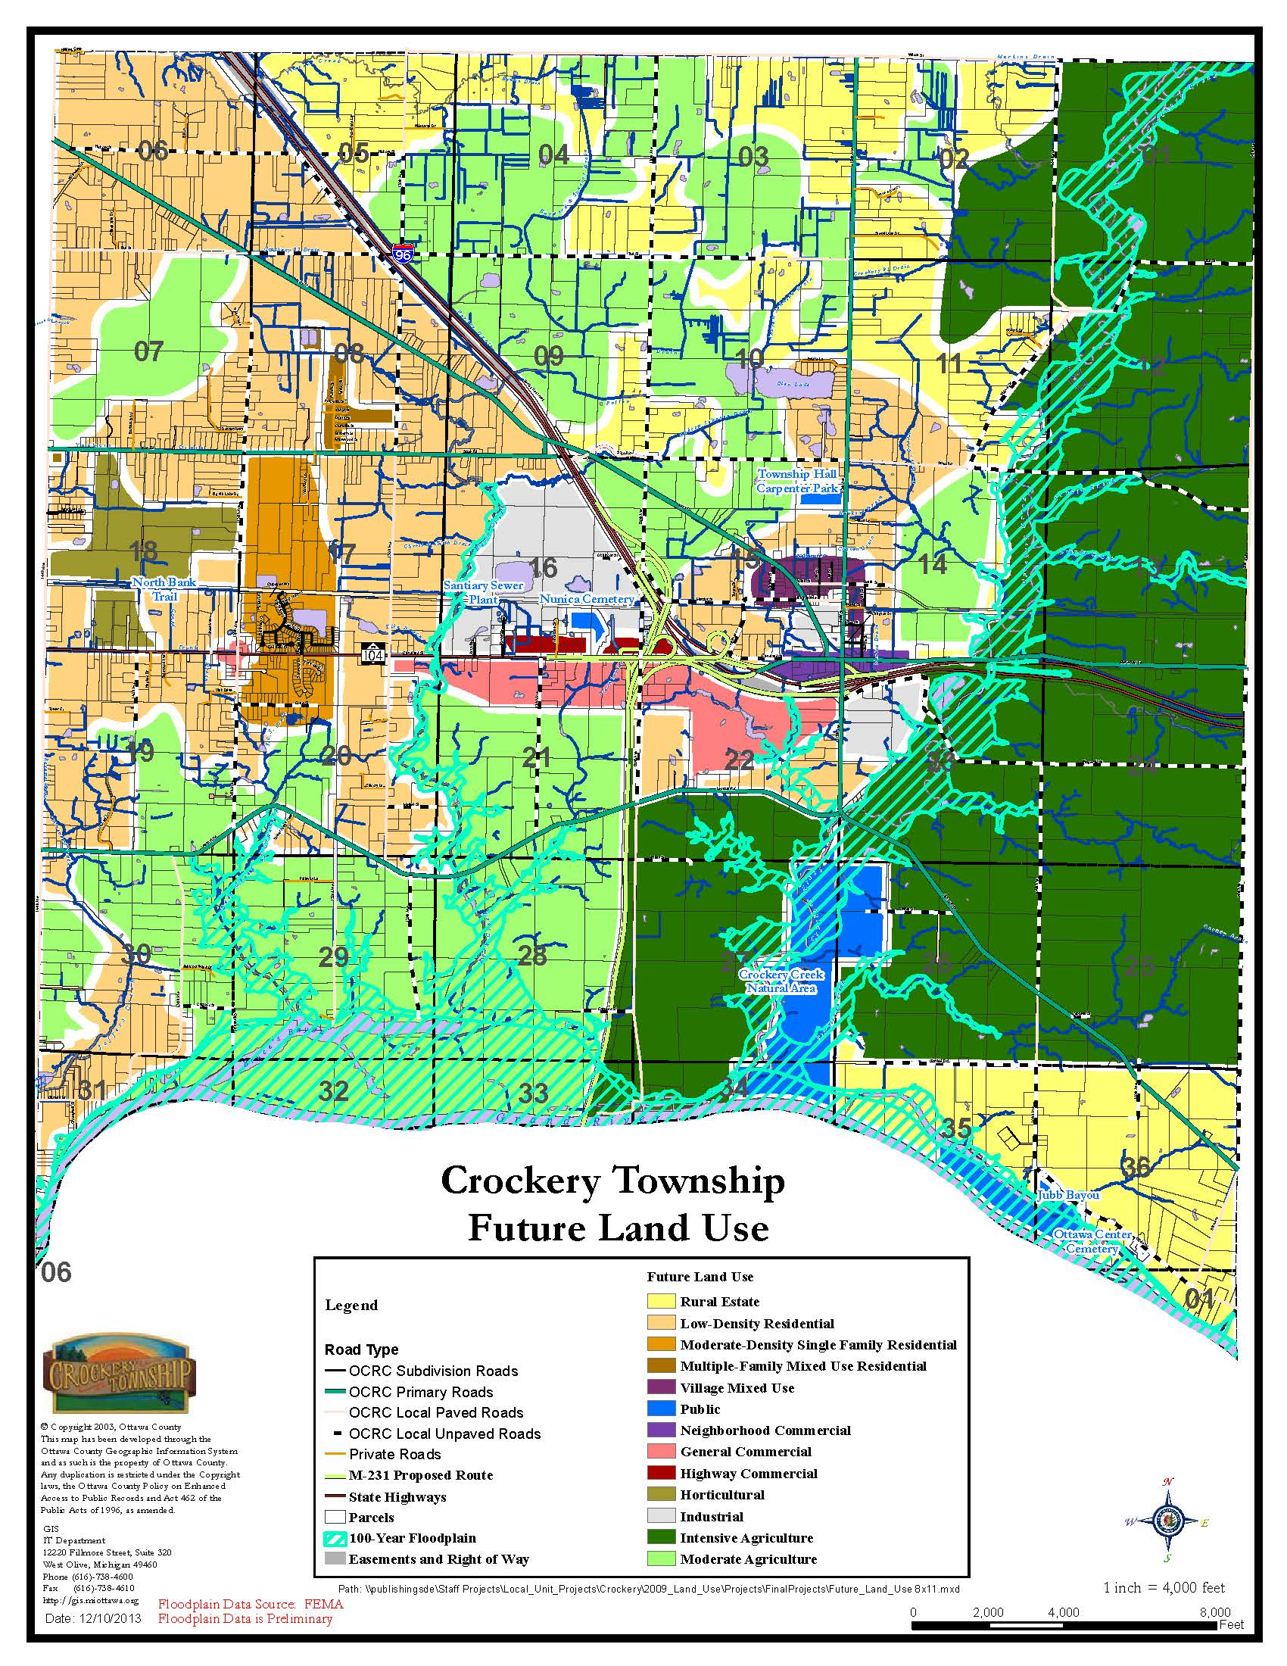
CHAPTER 9
PUBLIC INFRASTRUCTURE IMPROVEMENTS

Capital Improvements

A Comprehensive Plan includes information on community assets and goals, and provides a guide for growth and development. Capital improvement projects to be undertaken in the near future and long term, includes policies to achieving development goals of the Comprehensive Plan. The Planning Commission’s responsibility to review public improvements for consistency with the local master or Comprehensive Plan has been incorporated in MCL 125.39 of the Municipal Planning Act.

The statute says that no public facility (public street, square, park, open space, public building, or structure) shall be built or authorized until it has been approved by the Planning Commission. The implication is that the Planning Commission should have some reasonable standard for reviewing requests or recommendations for public improvements. Those requests are to have a basis in the Comprehensive Plan. The logical and time-tested means of following through on the Comprehensive Plan recommendations for public improvements is to establish a mechanism for determining the phasing, costs and revenue sources for those improvements (i.e., a capital improvements plan).

In addition, on February 11, 2013, the Crockery Township Board approved a Tax Increment Financing and Development Plan as a tool to correct and prevent deterioration in business districts. The Plan was prepared by the Township’s Corridor Improvement Authority, and provides a mechanism to plan, organize, and implement the revitalization of the Township’s business corridor. Tax Increment Financing provides a way to finance the planning and development needed to stimulate change in the Township. The primary intention of the Crockery Township CIA is to encourage economic growth through proper planning and provision of necessary and desirable public improvements.

Proposed Projects

Proposed projects contained in this Comprehensive Plan include:

- Water Storage Tank Interior and Exterior - Remove the existing roof coating by abrasive blast cleaning and application of a three-coat epoxy system. Blast clean all rusted and abraded surfaces. Repaint all interior prepared surfaces and pit piping with two-coat epoxy system. Replace expansion joint, fill pipe insulation, and install a frost-free mud valve in the diaphragm plate. Paint the exterior tank surface with a three-coat polyurethane system. Modify the access tube at the center of the roof.

- Wastewater Treatment Plant - Improvements are required at the wastewater treatment facility, located within the Township, that include providing increased capacity for the wastewater plant, installation of an additional clarifier, and installation of a chemical feed system. These improvements are considered critical to future economic expansion and development within the Township. Replace treatment membranes. Add additional treatment cell for additional capacity.

- Municipal Water System - New water mains should be installed to correct existing reliability problems and to eliminate dead-ends. This would increase pressure as well as improve fire protection capabilities, causing a potential reduction in insurance costs to businesses and, therefore, encouraging more development. It would include new 10 and 12-inch water mains in various places to accommodate pressure, service, and fire-flow requirements. Improvements would include installation of fire hydrants, valves, and other required appurtenances.

  - M-104 between 144th Avenue and 136th Avenue - connecting the dead end water main on M-104 east of 136th Avenue west to 144th Avenue. The project includes 5,150 feet of 12-inch water main along with valves, boxes, fittings, fire hydrants and restoration of disturbed areas.

  - Apple Drive and State Road - connecting the dead-end on Apple Road east of 120th Avenue west to State Road and under I-96 connecting to the dead-end on State Road west of 130th Avenue. This would complete a loop of the system. There would be 6,750 feet of 12-inch water main placed along with valves, boxes, fittings, fire hydrants and restoration of disturbed areas. This project requires a 250-foot bore and jack under I-96.

  - 136th Avenue and Leonard Road - connecting the dead-end on Leonard Road west of 136th Avenue to the dead-end on M-104 east of 136th Avenue. This would create a loop in the system and eliminate two existing dead-ends. There would be 4,850 feet of 12-inch water main placed along with valves, boxes, fittings, fire hydrants and restoration of disturbed areas. This project requires a 75-foot bore and jack under the drainage ditch at Cone Street.

  - Cone Street - connecting Cone Street to the dead-end on Stoneway Drive and 144th Avenue. There would be approximately 900 feet of 12-inch water main placed along with valves, boxes, fittings, fire hydrants and restoration of disturbed areas.

  - State Road between I-96 and 112th Avenue - connecting the dead-end on State Road east of I-96 with the water main on 112th Avenue. This would complete a loop of the system. There would be 6,100 feet of 12-inch water main and 1,650 feet of 8-inch water main placed along with valves, boxes, fittings, fire hydrants and restoration of disturbed areas.

  - Cleveland Street Dead end East of I-96 to 12” in Grand Trunk Railroad

  - South Side of I-96 along 112th Avenue

- Storm Drainage System - Consideration should be given to improve drainage in some areas of the Township. Drainage improvements may include land and easement acquisition and the installation of culverts, underground piping, open ditches, and retention/detention basins. The proposed improvements would include concrete pipes, manholes, and catch basins.

- Streetscape and Sidewalk Improvements (112th Avenue from Cleveland Street to South Street) - Visual improvements, such as new street lighting, banners, and landscaping, are highly visible and have tremendous impact on a community. These accents help to improve the overall community image and help to foster a positive business environment in the area. Actual styles, types, and locations would be determined during the design study. Additional enhancements including pedestrian scale lighting, signage, and site furniture such as benches, waste receptacles, and planters should be considered. The selection and placement of all items should express basic design principles. Each element should complement the others. Sidewalk improvements and additions may be included in the overall scope of this project. Focal points should be established at primary entrances to the downtown area calling attention to the downtown. The focal points help maintain a consistent identity using signage, lighting, plantings, etc. Streetscape improvements would include intersection improvements at M-104 (Cleveland Street) and 112th Avenue, such as proper identification of pedestrian crossings, signalization, curb cuts/ramps, and adequate waiting space with minimized crossing distances for pedestrians. Streetscape improvements include six-foot (6’) wide sidewalk, planters, lighting, trees and irrigation for both sides of the street. Lighting costs are affected by type, quality and number and extent of fixtures.

- Streetscape and Sidewalk Improvements (M-104 from 120th Avenue to 124th Avenue) - Visual improvements, such as new street lighting, banners, and landscaping, are highly visible and have tremendous impact on a community. These accents help to improve the overall community image and help to foster a positive business environment in the area. Actual styles, types, and locations would be determined during the design study. Additional enhancements including pedestrian scale lighting, signage, and site furniture such as benches, waste receptacles, and planters should be considered. The selection and placement of all items should express basic design principles. Each element should complement the others. Sidewalk improvements and additions may be included in the overall scope of this project. Focal points should be established at primary entrances to the downtown area calling attention to the downtown. The focal points help maintain a consistent identity using signage, lighting, plantings, etc. Streetscape improvements would include intersection improvements at M-104 (Cleveland Street) and 112th Avenue, such as proper identification of pedestrian crossings, signalization, curb cuts/ramps, and adequate waiting space with minimized crossing distances for pedestrians. Streetscape improvements include six-foot (6’) wide sidewalk, planters, lighting, trees and irrigation for both sides of the street. Lighting costs are affected by type, quality and number and extent of fixtures.

- Parks and Recreation – While bike paths and trails have dominated the discussion about recreation in recent years, it is important to remember the need for smaller neighborhood parks and small-scale recreational opportunities for both children and adults. The acquisition of park land in the west ½ of the Township could provide much need recreational opportunities for many Township residents who are currently underserved.

- North Bank Trail Improvements - Continue the existing trail east through Crockery and into Polkton Township. This proposed trail length is approximately 4 1/4 miles as a recreational amenity for Township residents depending on final route determination.. This project would consist of a ten-foot (10’) wide trail along the former railroad grade, Murphy Street and east of 112th Street in Nunica. The intersection of Michigan Avenue and the Trail would make an excellent location for expanding the recreational aspects of the trail as well as a means of access to the trail as a starting/ending point and staging area.

- Sanitary Sewer System Expansion - Expand wastewater collection system into the industrial park and toward the Nunica area.

  - Sanitary Sewer Improvements (North side of M-104 from Power Drive east to 120th Avenue) - This project will provide sanitary sewer service to the area north of M-104 along Power Drive and the developed area to the immediate east as shown in Figure 1 of the Crockery Township Wastewater Collection System Master Plan completed in 2008. In order to service the area by gravity sewer a pump station will need to be located near the wastewater treatment plant. Completion of this portion of sewer will allow connection of sanitary sewer from the east and areas along the south side of M-104.

  - Sanitary Sewer (South side of M-104 from Power Drive east to 120th Avenue) - Provide sanitary sewer service to the areas along M-104 from Power Drive to a proposed pump station located to the west of 120th Avenue. The extension to 120th Avenue will allow for service to the frontage along M-104. The 2008 Wastewater Collection System Master Plan includes this cost for all areas east of 120th. The Plan also calls for providing service to the SW corner of 120th and M-104 and outlets for development on the south side of M-104 along the route. Future service to the east from downtown Nunica and areas to the east will be through the pump station proposed near 120th Avenue.

  - Sanitary Sewer (120th Avenue to 112th Avenue north and south of I-96) - Provide sanitary sewer service to the main downtown area of 112th Avenue and along Cleveland from 112th to the east to the Township corridor limits. Sanitary sewer is to be provided along 112th Avenue to serve as the main collector sewer for future service to the immediate areas outside of the corridor. The Wastewater Collection System Master Plan includes the sanitary sewer for those areas within the corridor boundary. Gravity sewer is proposed to discharge to a pump station west of 112th along M-104, and pump to the west side of I-96 and into the gravity sewer along M-104 to the west of I-96. Service to the south of I-96 is also included.

- Property/Land Acquisition - It may be desirable and/or necessary to acquire, repair, or redevelop properties located throughout the Township in an effort to accomplish various improvement projects. Following acquisition it may be necessary to undertake site preparation activities, such as demolition, hauling debris, backfilling, drainage and grading, and excavation. Potential development projects include but are not limited to immediate expansion of commercial facilities. Additional property that could be leased or offered for private development in the future may be acquired by the Township as it becomes available. It may be necessary to obtain rights-of-way to be used as alleys in the core area to allow parking lot access and utility corridors. The Township may look at purchasing property along the railroad right-of-way for recreational use, such as a linear park, greater public access, public parking, or development property.

- Street and Sidewalk Improvements - It may be desirable and/or necessary to repair, or redevelop streets and sidewalks located throughout the Township in an effort to accomplish various improvement projects. It may be necessary to undertake activities such as paving, re-paving, and widening, including drainage and grading. It may be necessary to obtain additional rights-of-way to be used as access drives in the core M-104 areas to allow parking lot access, rear lot development and utility corridors. The Township may look at purchasing property along the railroad right-of-way for greater public access. The addition of sidewalks, paved streets and improved drainage would also provide a benefit to the Nunica area. The primary areas considered for improvement would be located adjacent to 112th Avenue and the M-104 (Cleveland Street) corridor. Sidewalks and connected pathways should be required in developing subdivisions.

